**Assembly Introduction:**

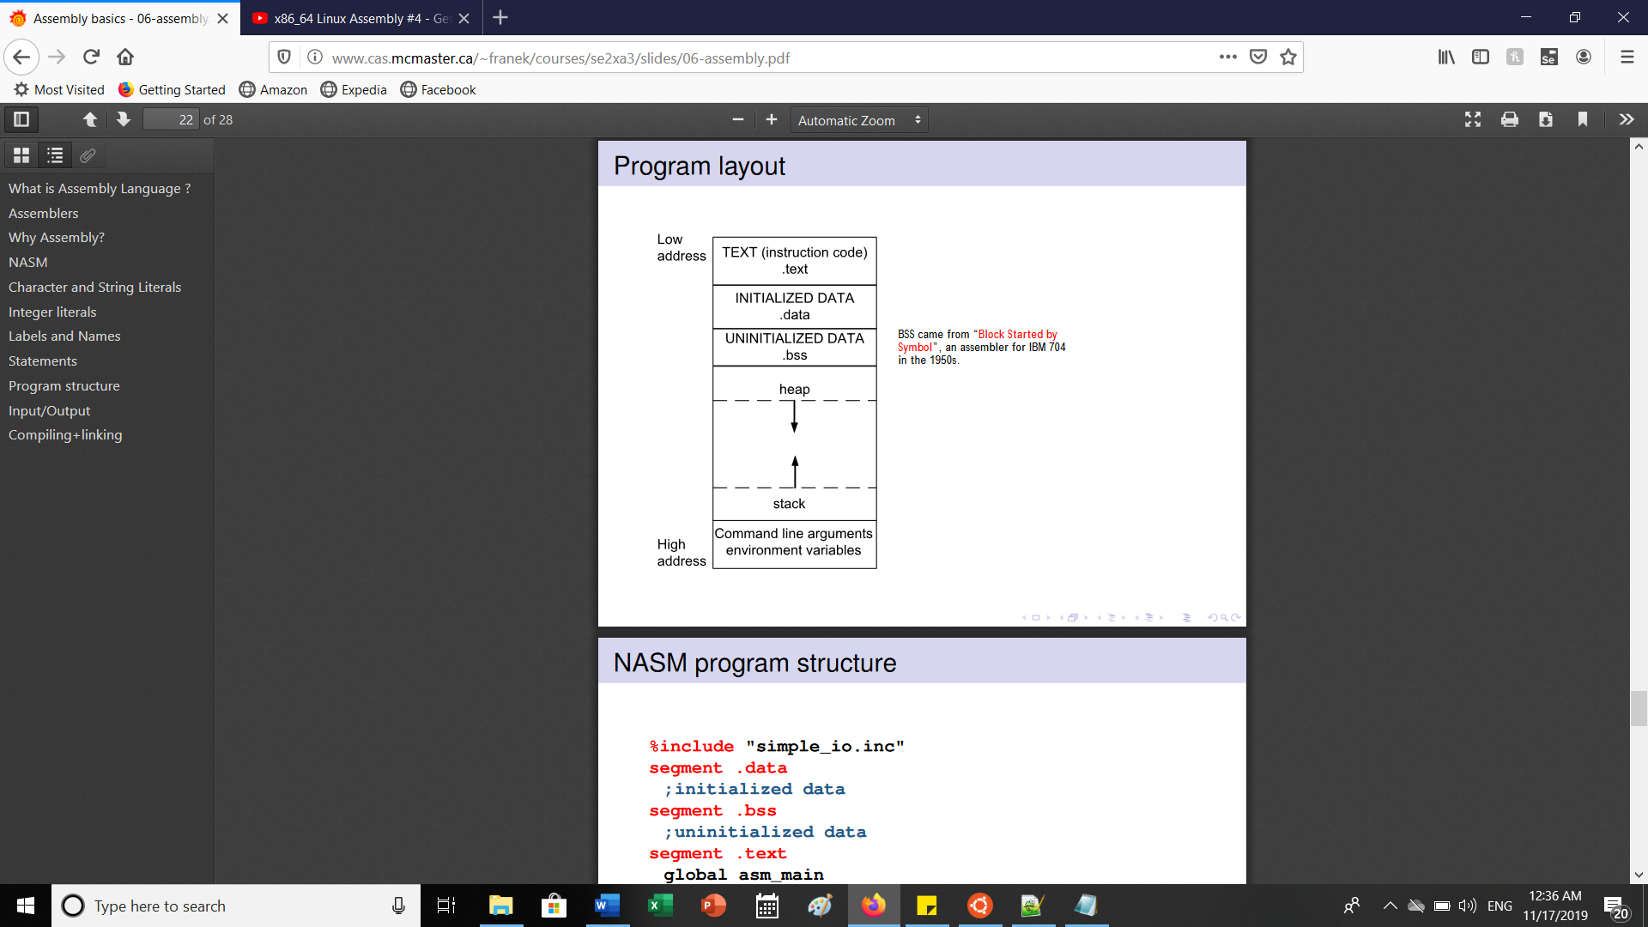

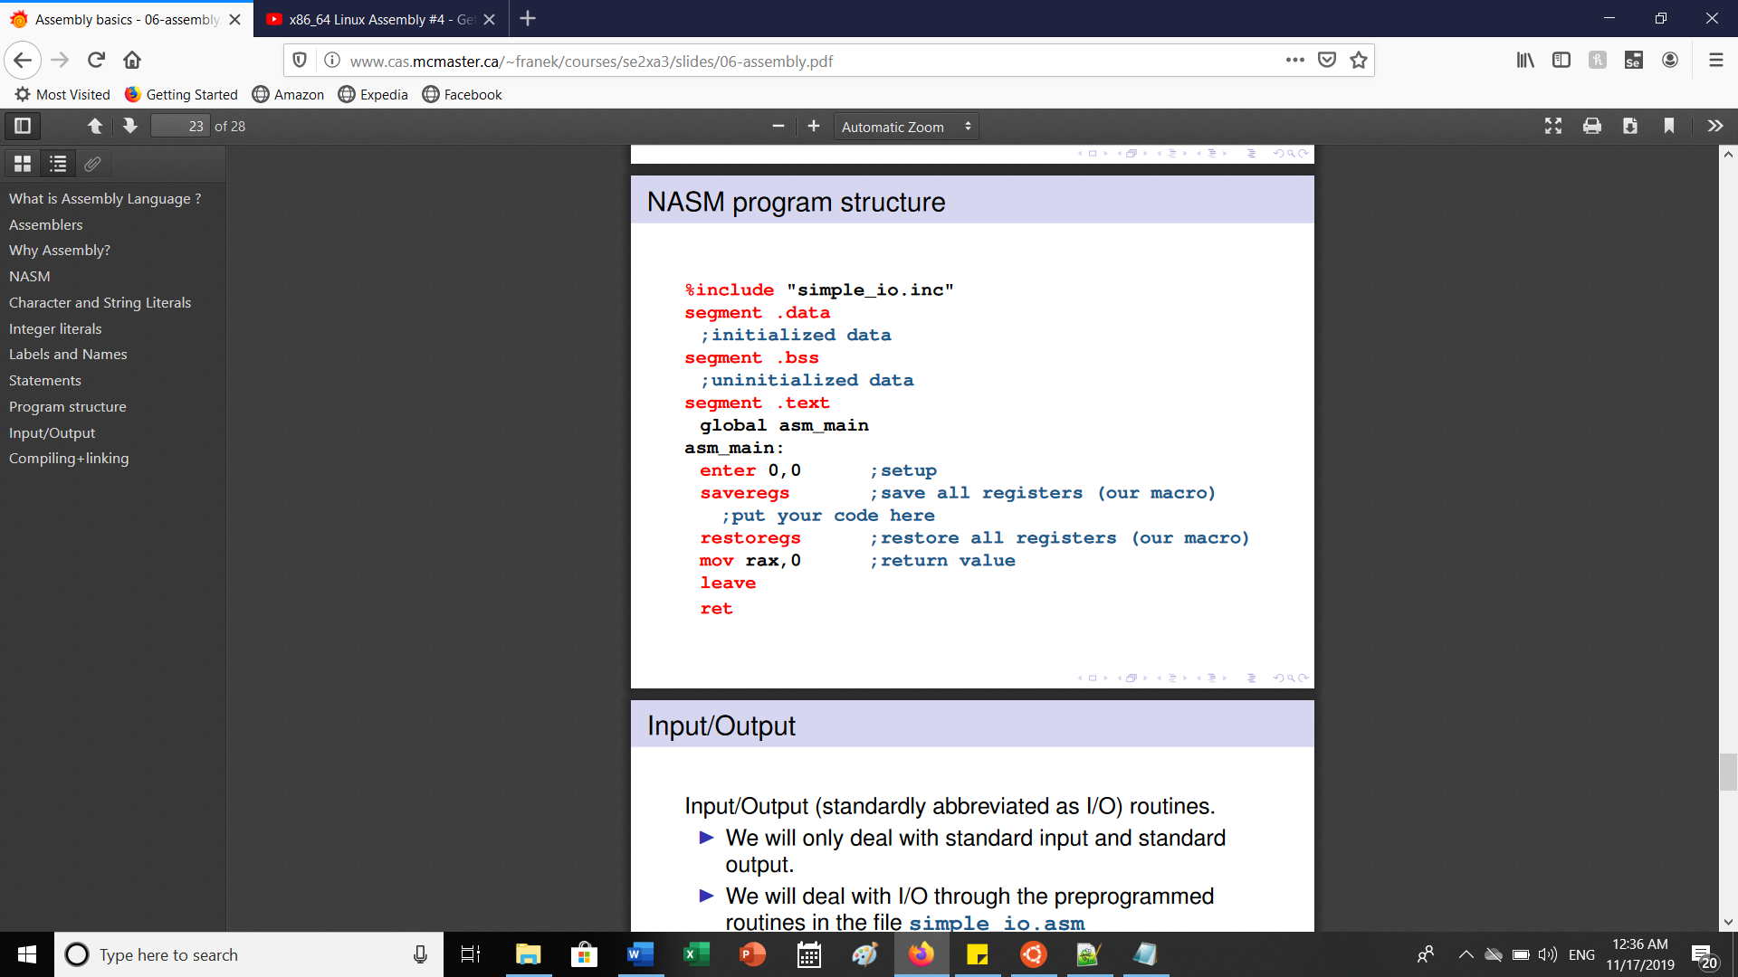

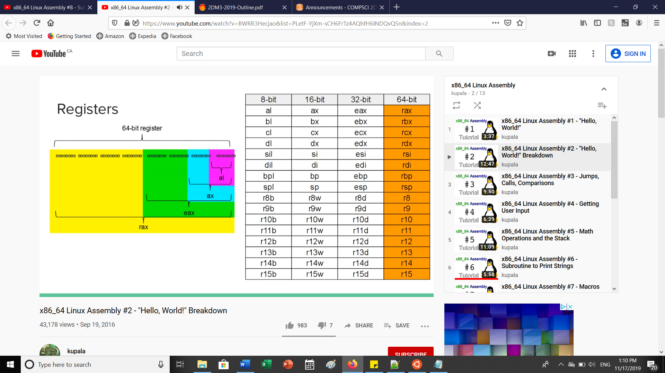

**TABLE OF SYSTEM CALLS**

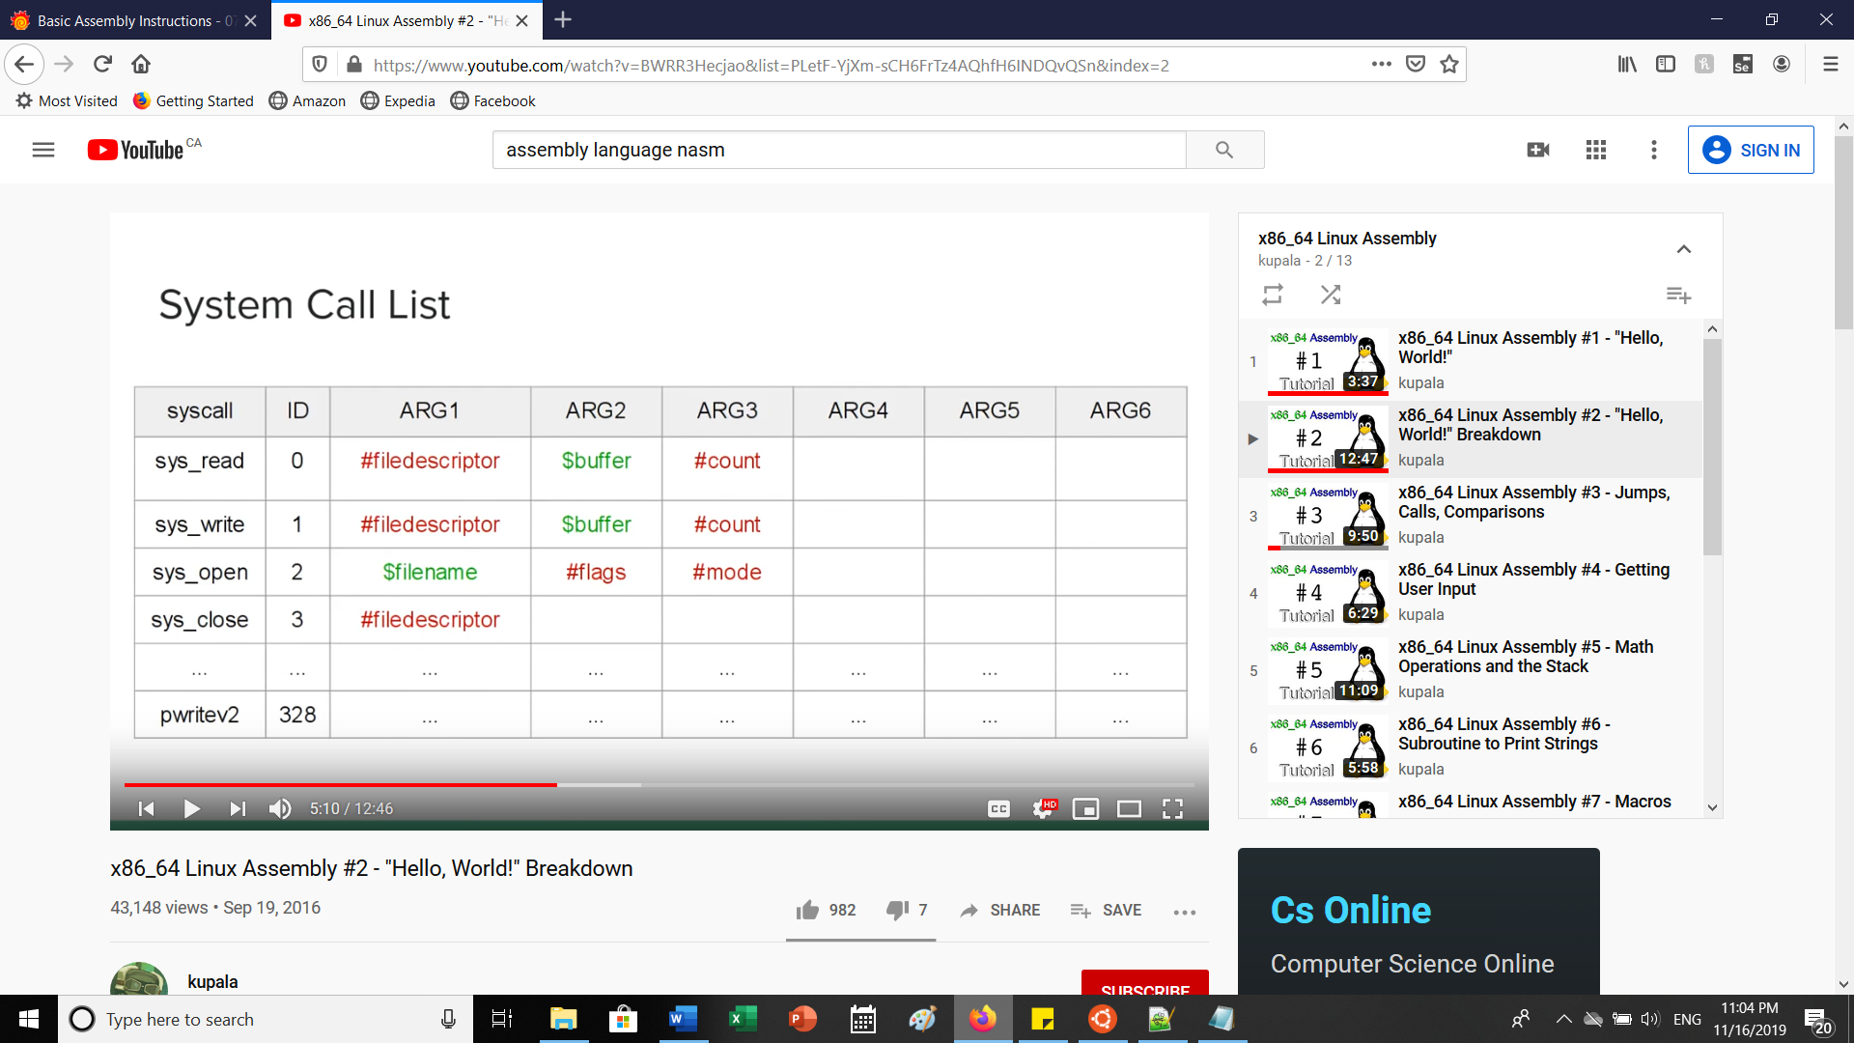

rdx is the register for ID. 0 is for reading input, 1 is for writing output

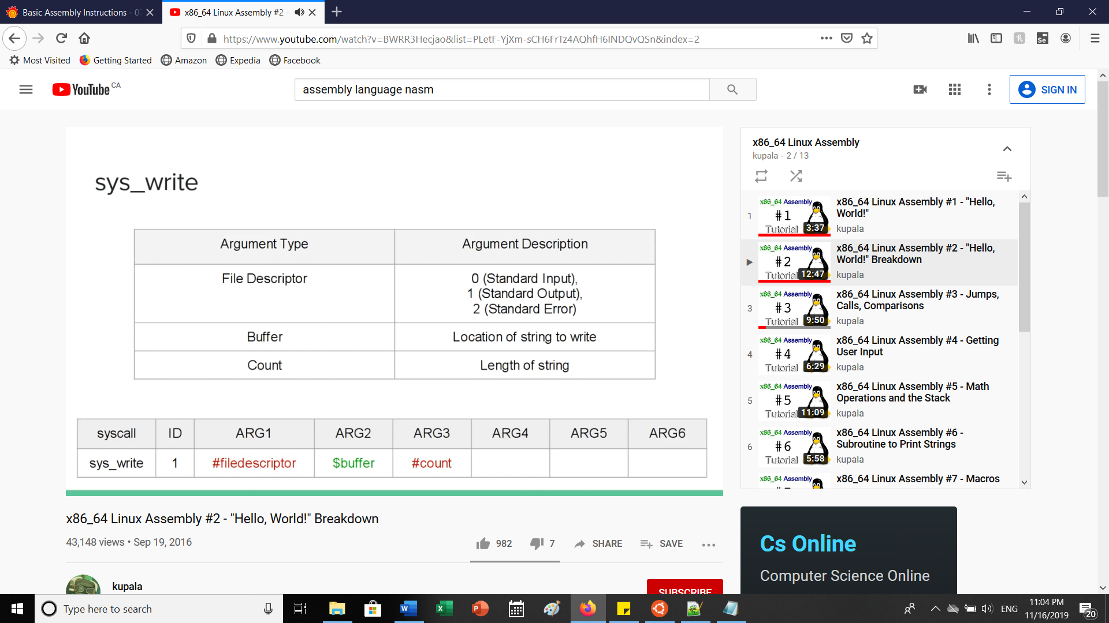 **IMPORTANT FOR REGISTERS**

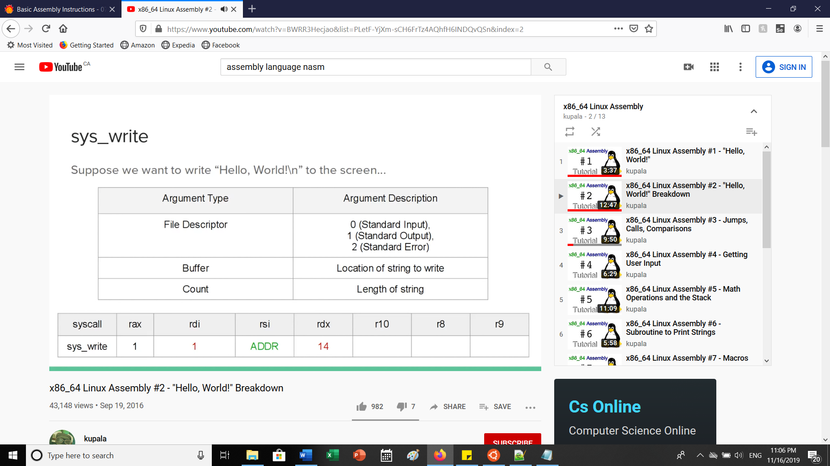

The registers always go in this order. The rax is essentially the ID and is set to 1 to indicate sys_write as shown in the first image. The rdi is for the File descriptor and is set to 1(standard output). The rsi is for storing the address of the label, in this case it is the ‘text’. The rdx is the register used to keep track of length of the string.

Mov is used to move values around from registers,etc. The **syscall** is needed right after all registers are initialized/setup to call the variations.

Sys_exit has ID(rax) is 60 and rdi is 0 which is the error code. This is needed to exit the program gracefully.

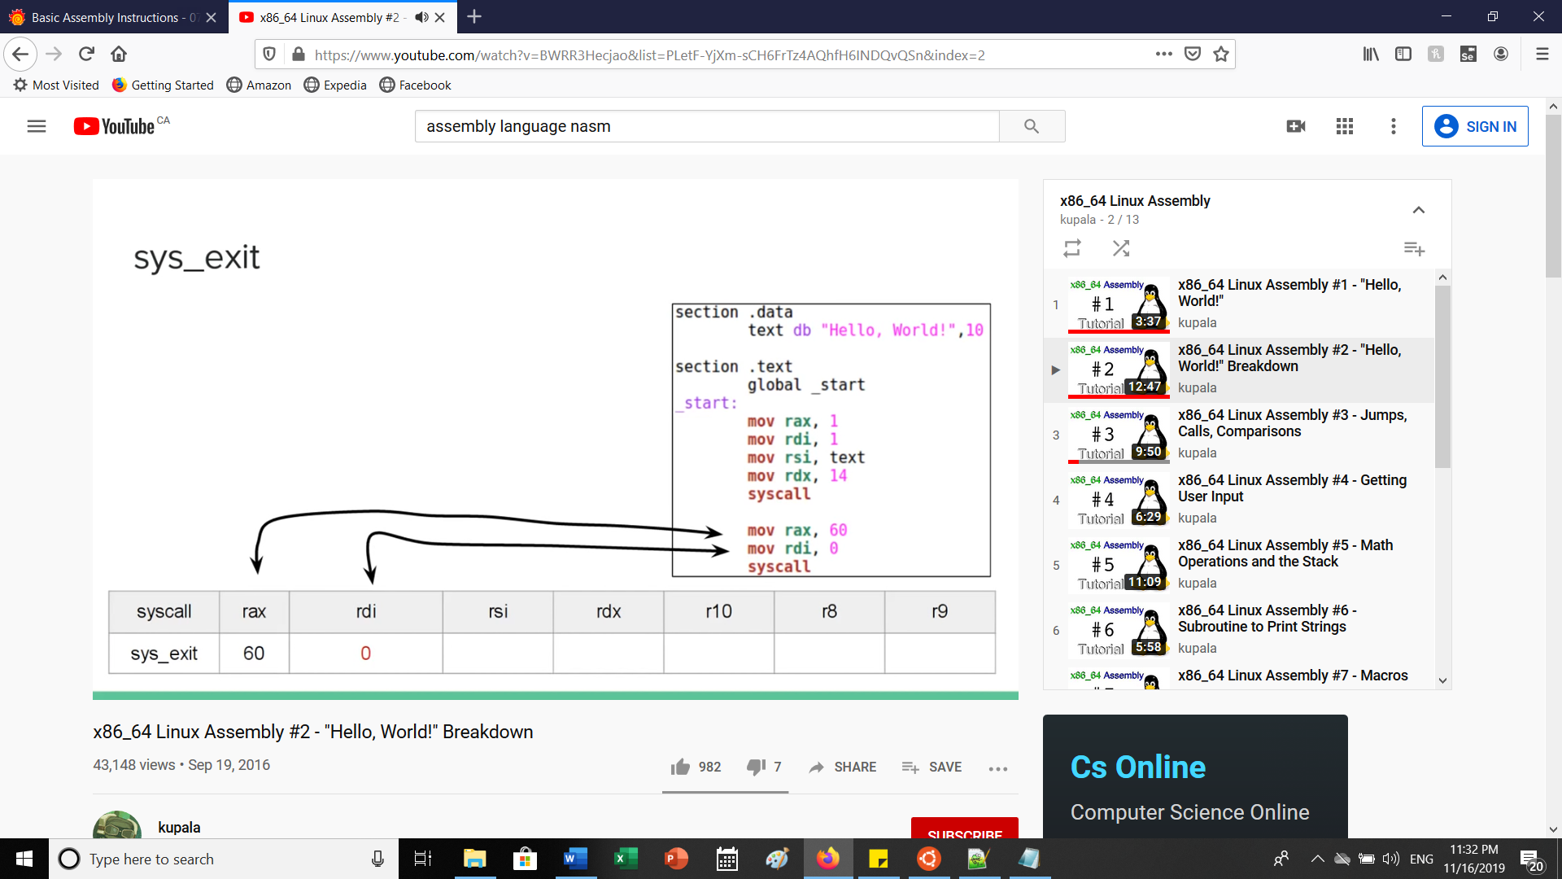

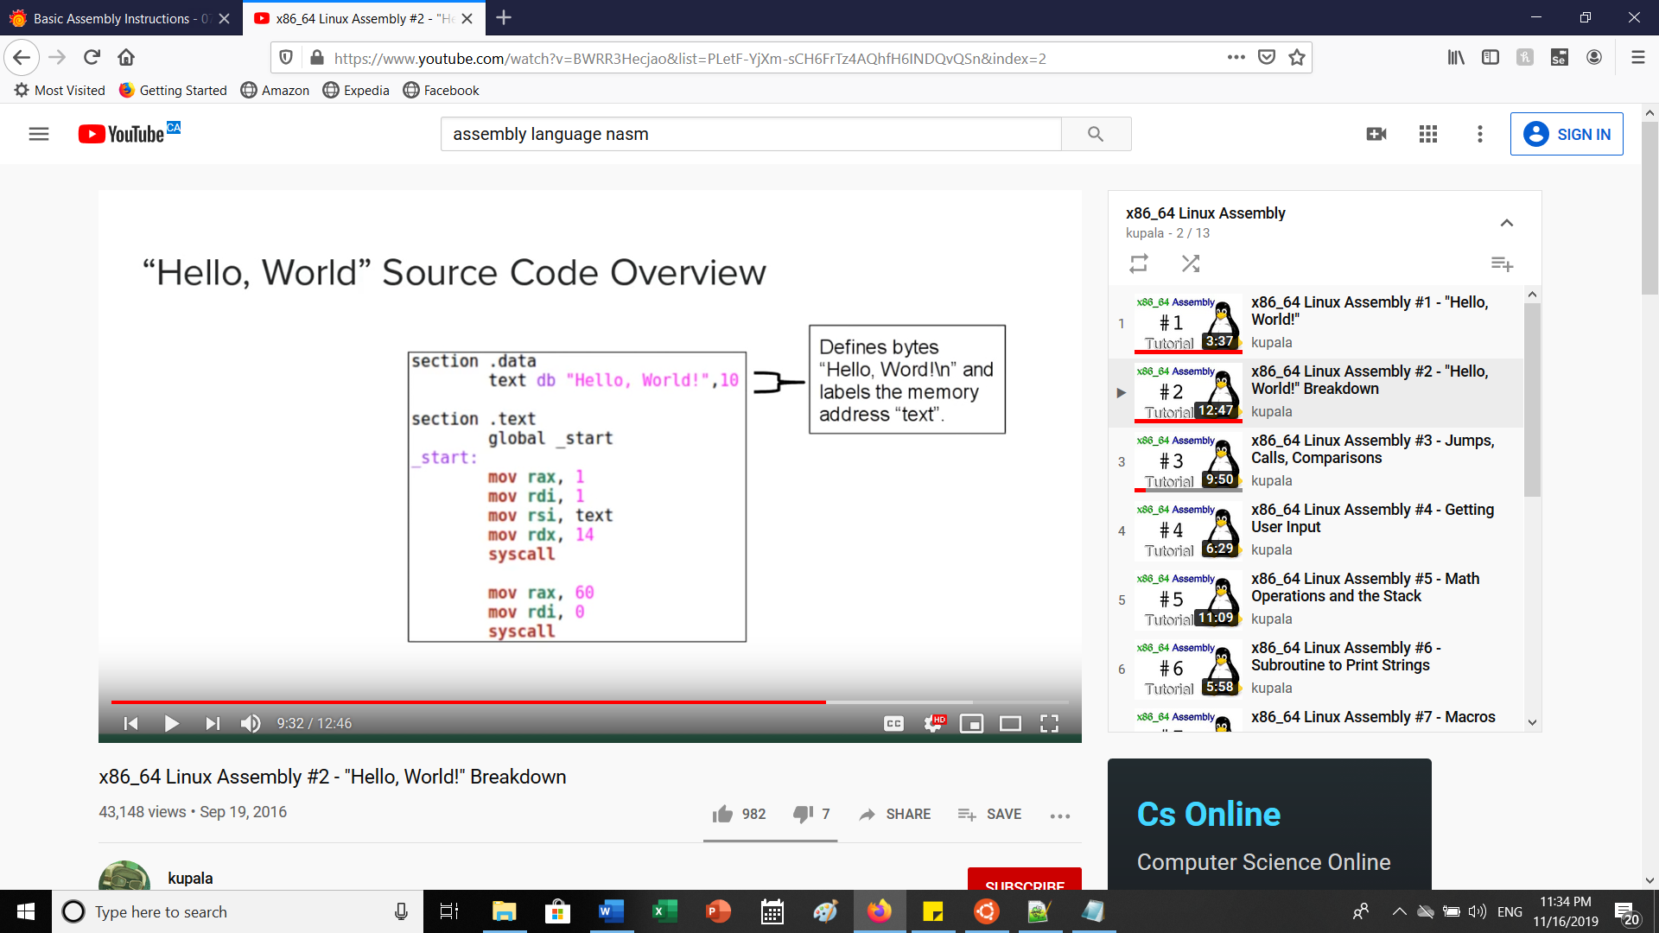

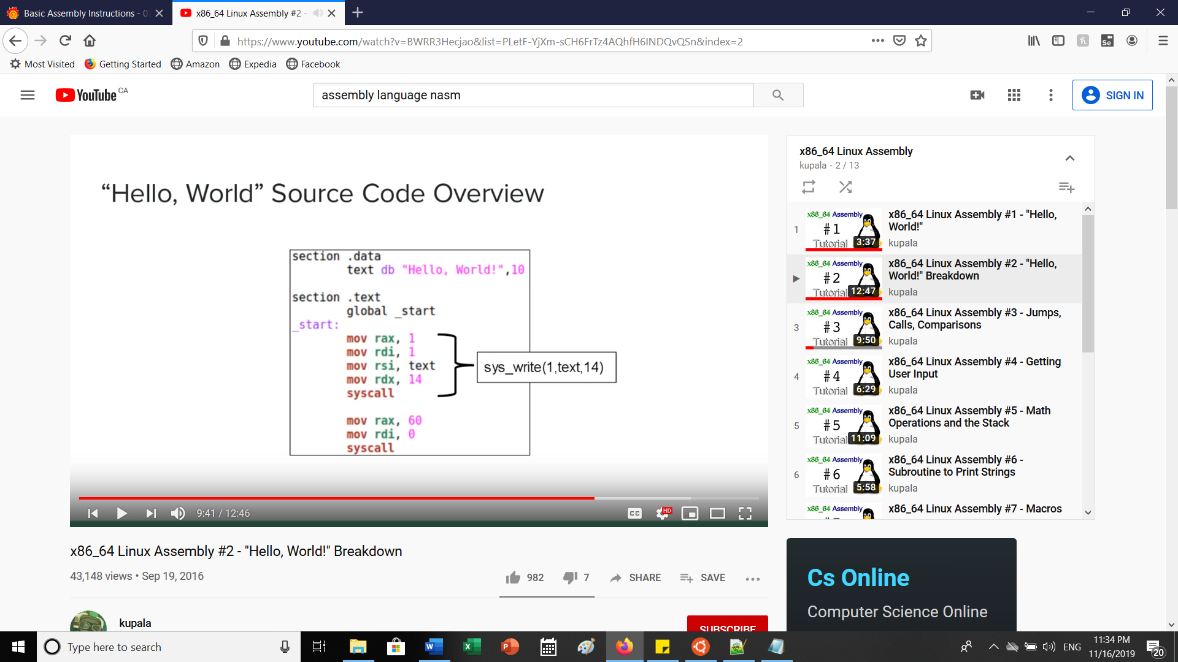

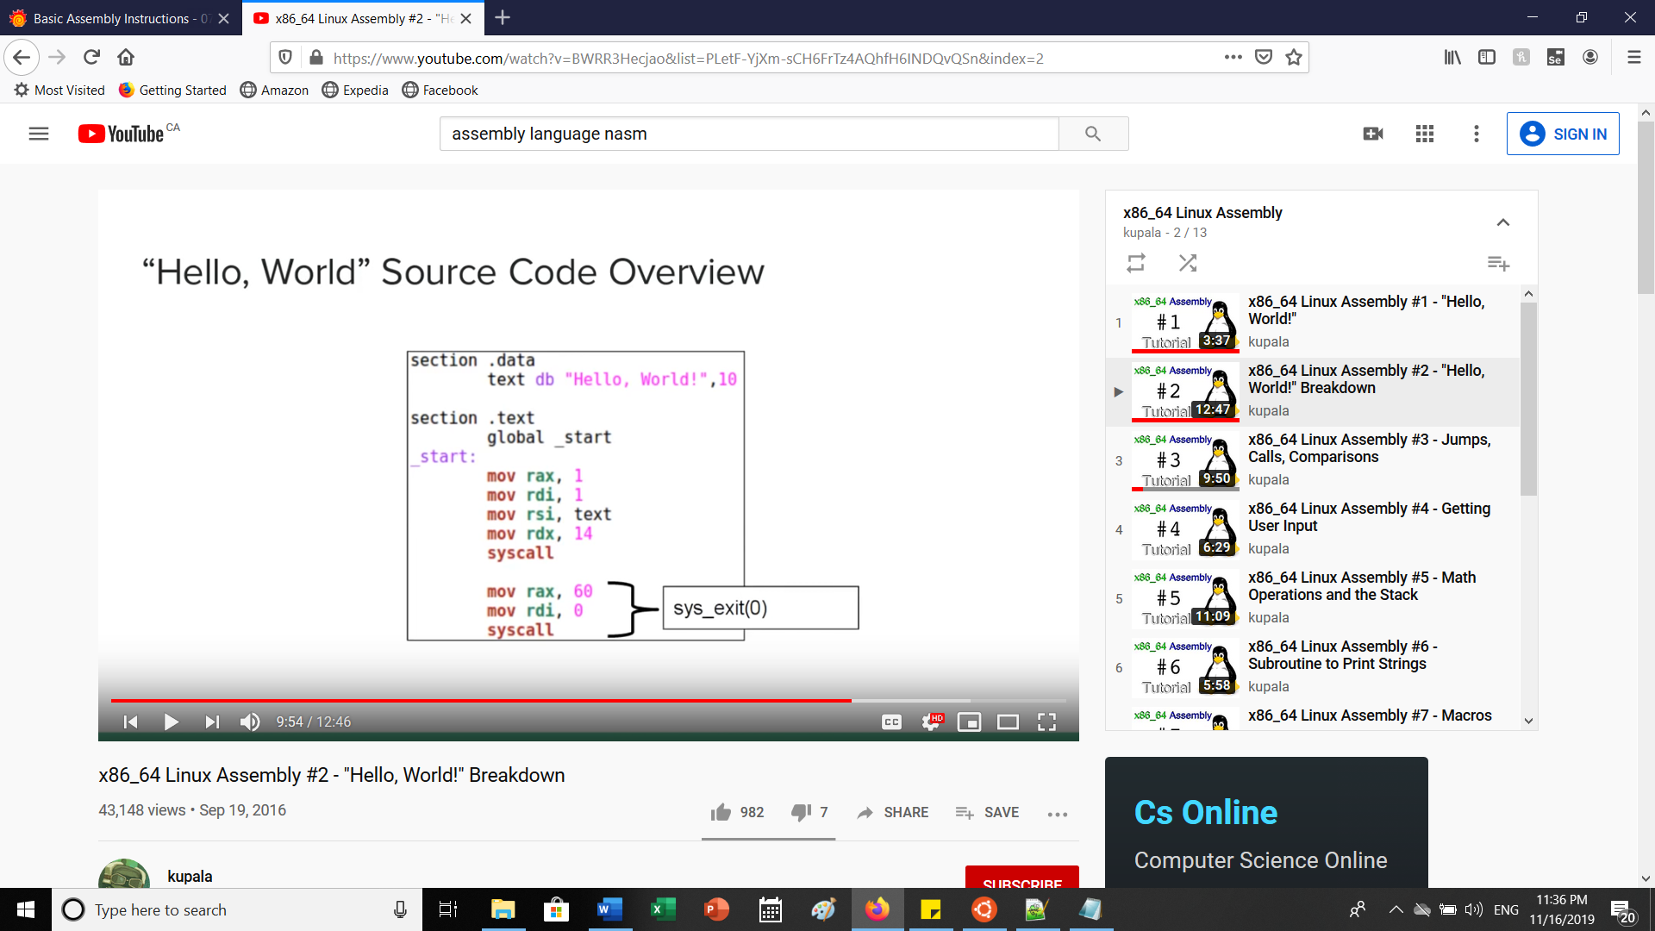

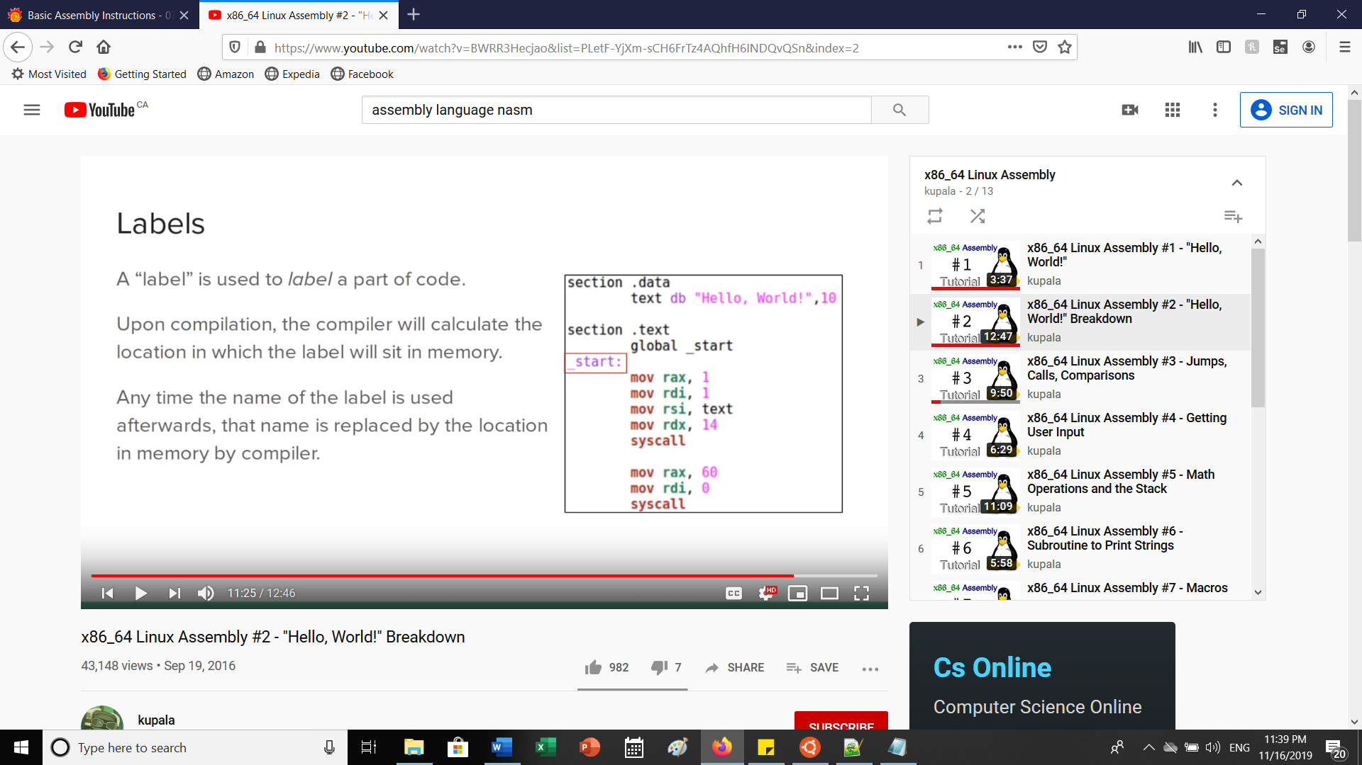

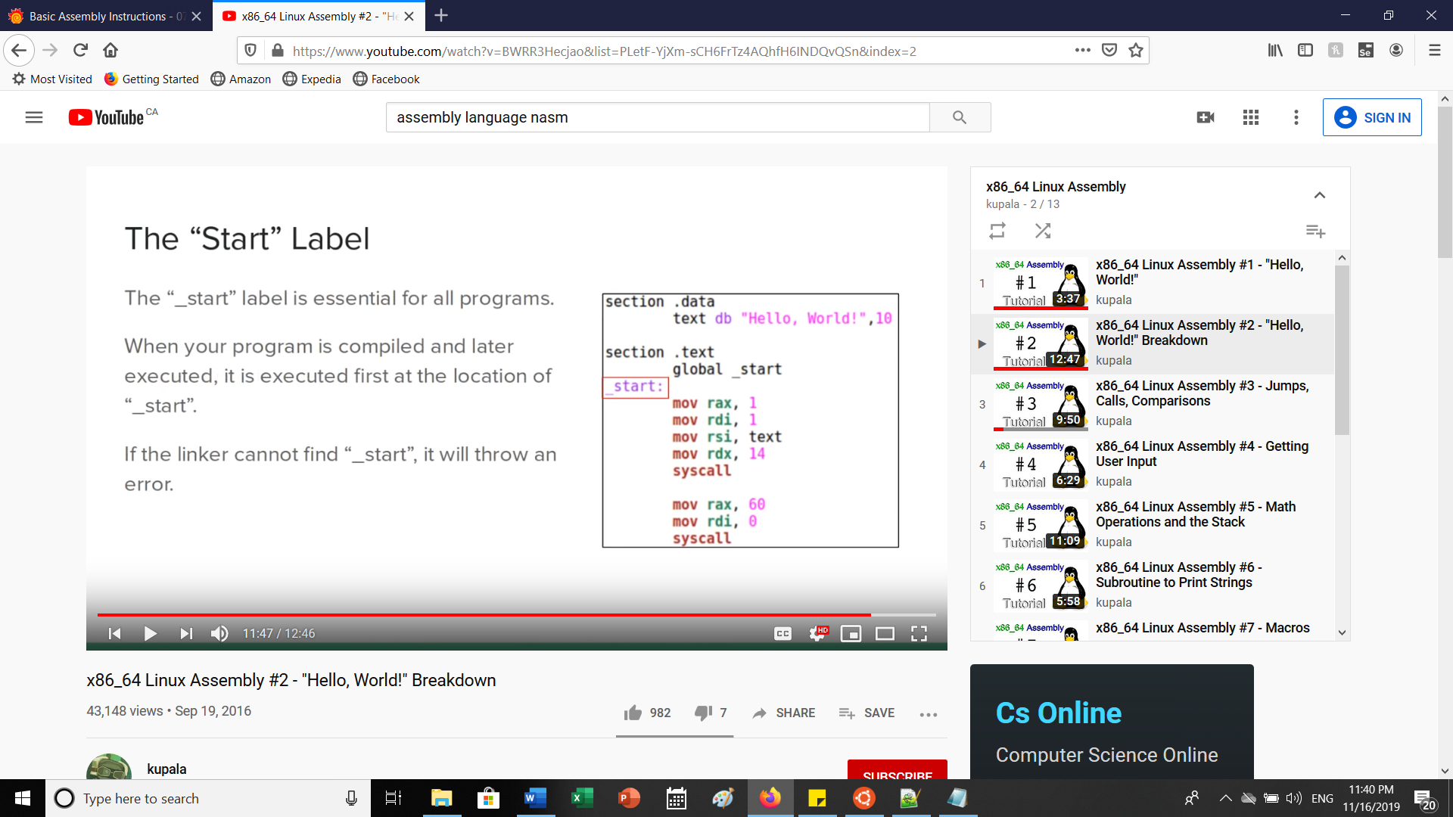

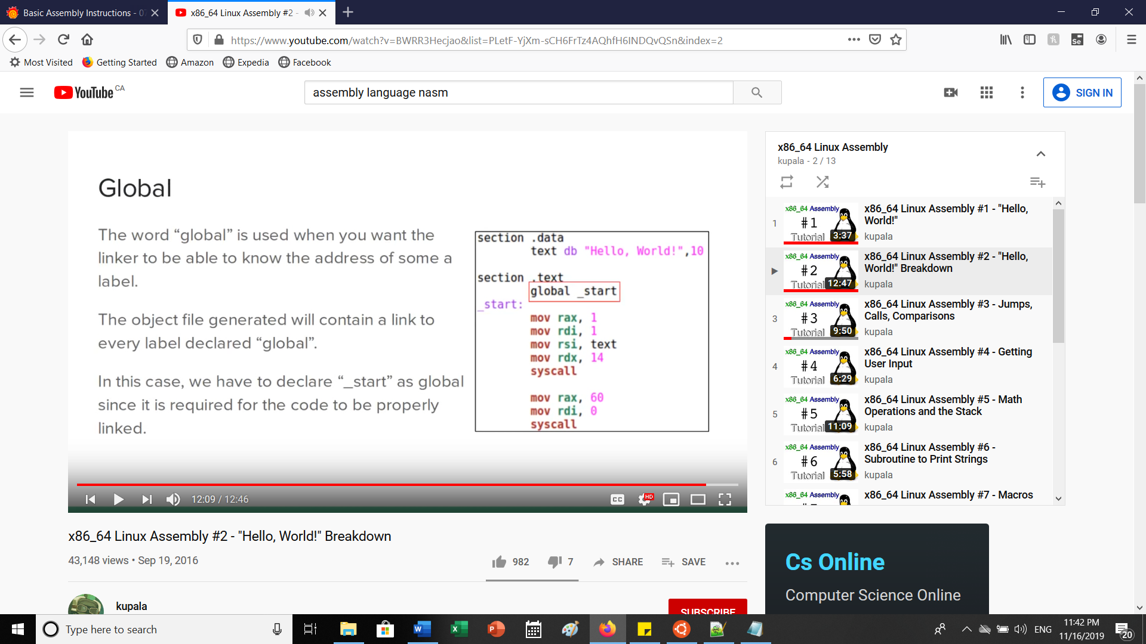

**PART B: Assembly Arithmetic**

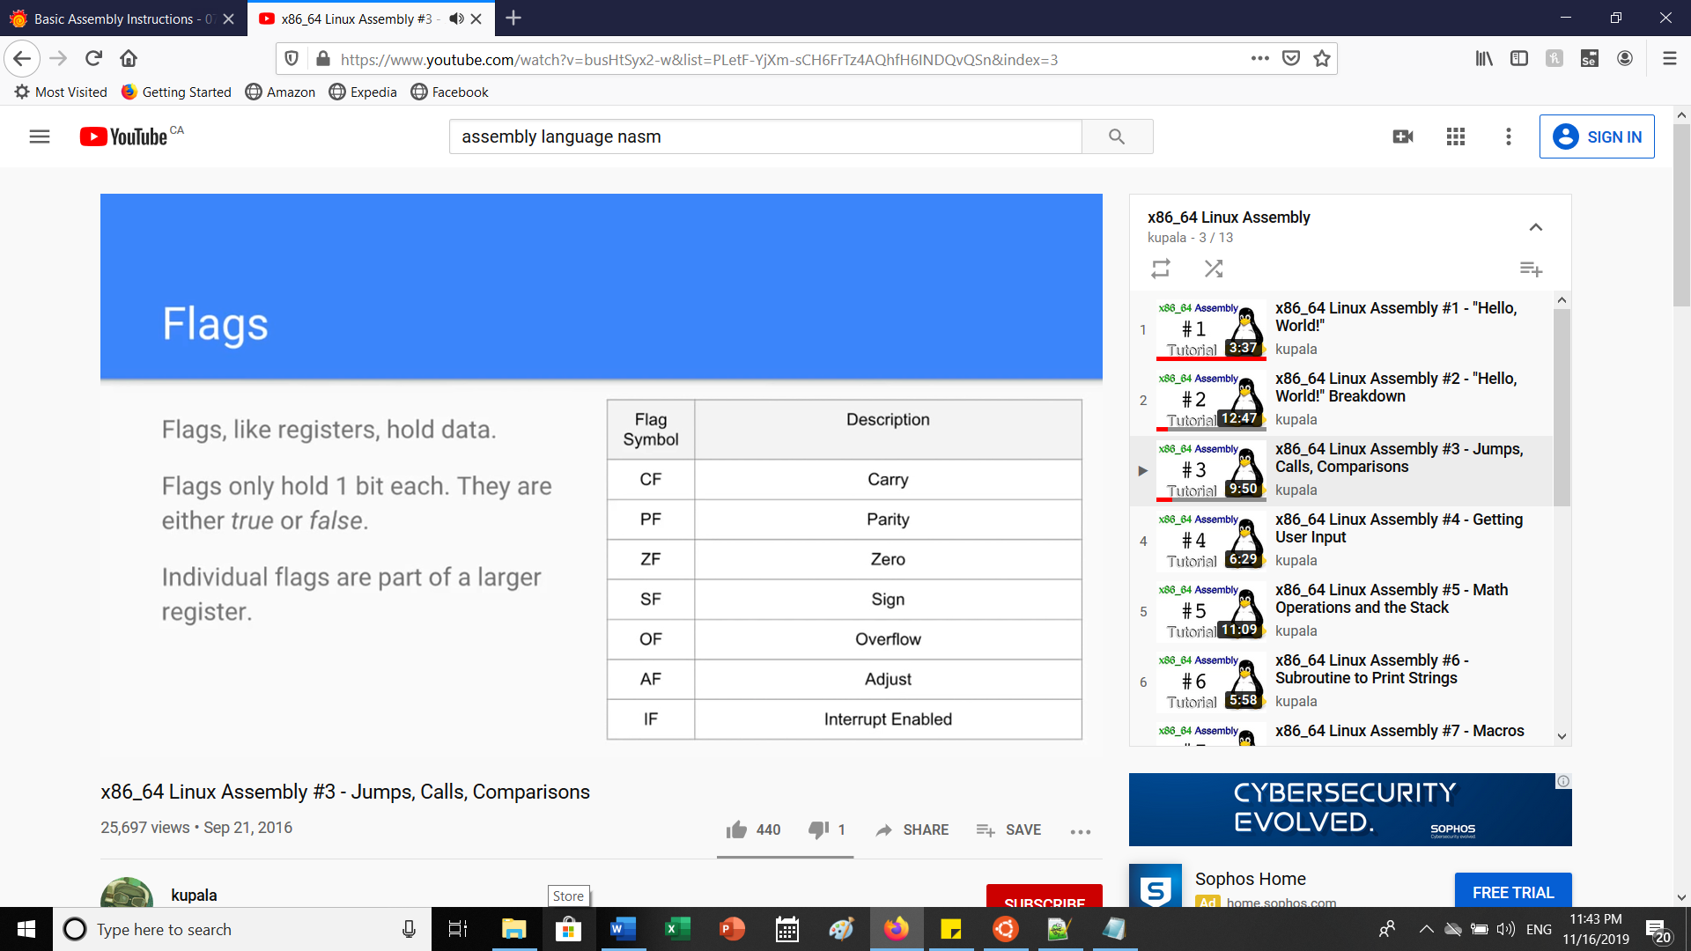

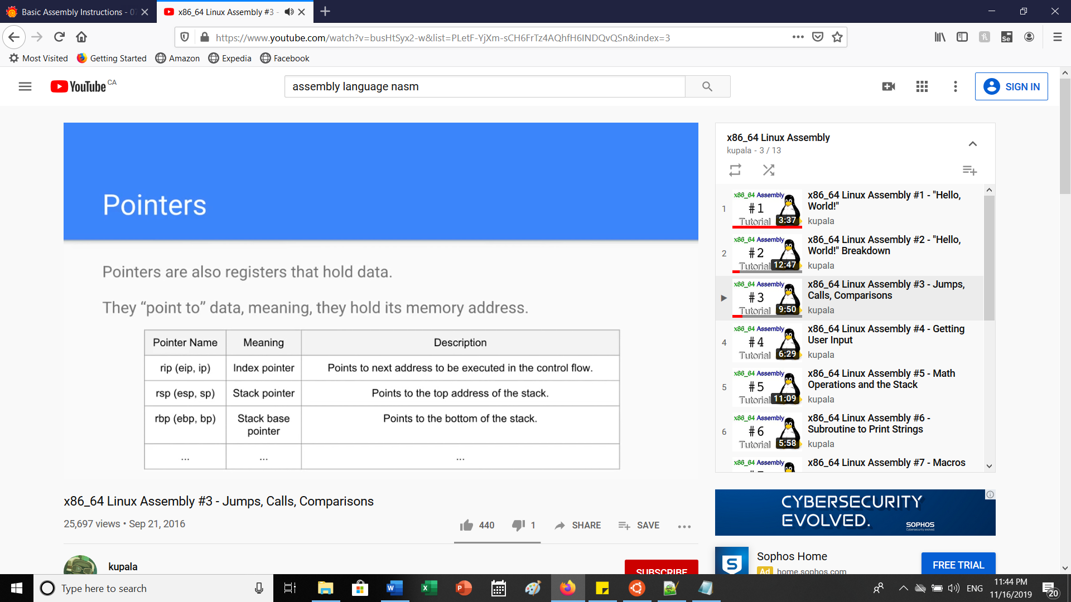

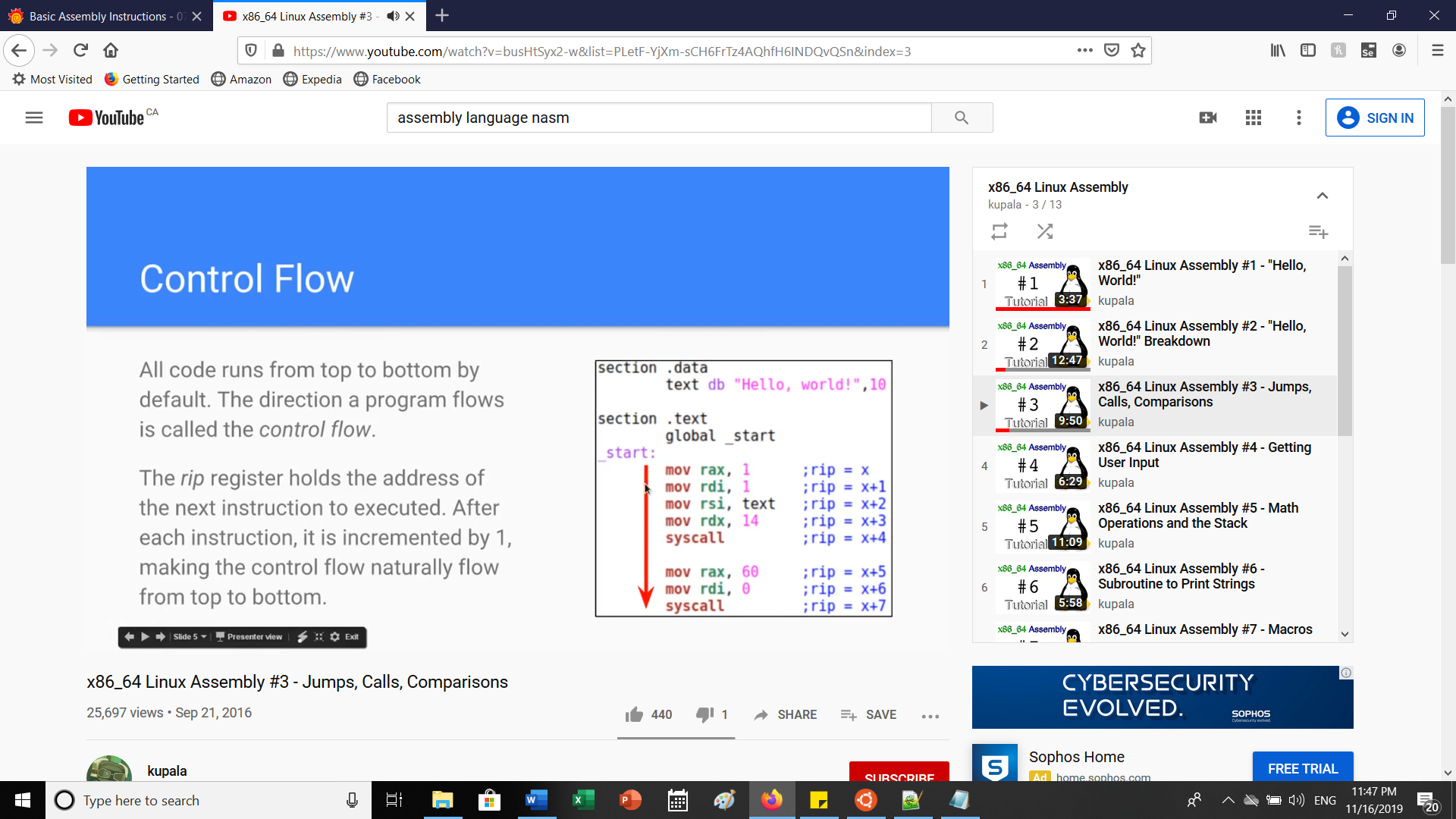

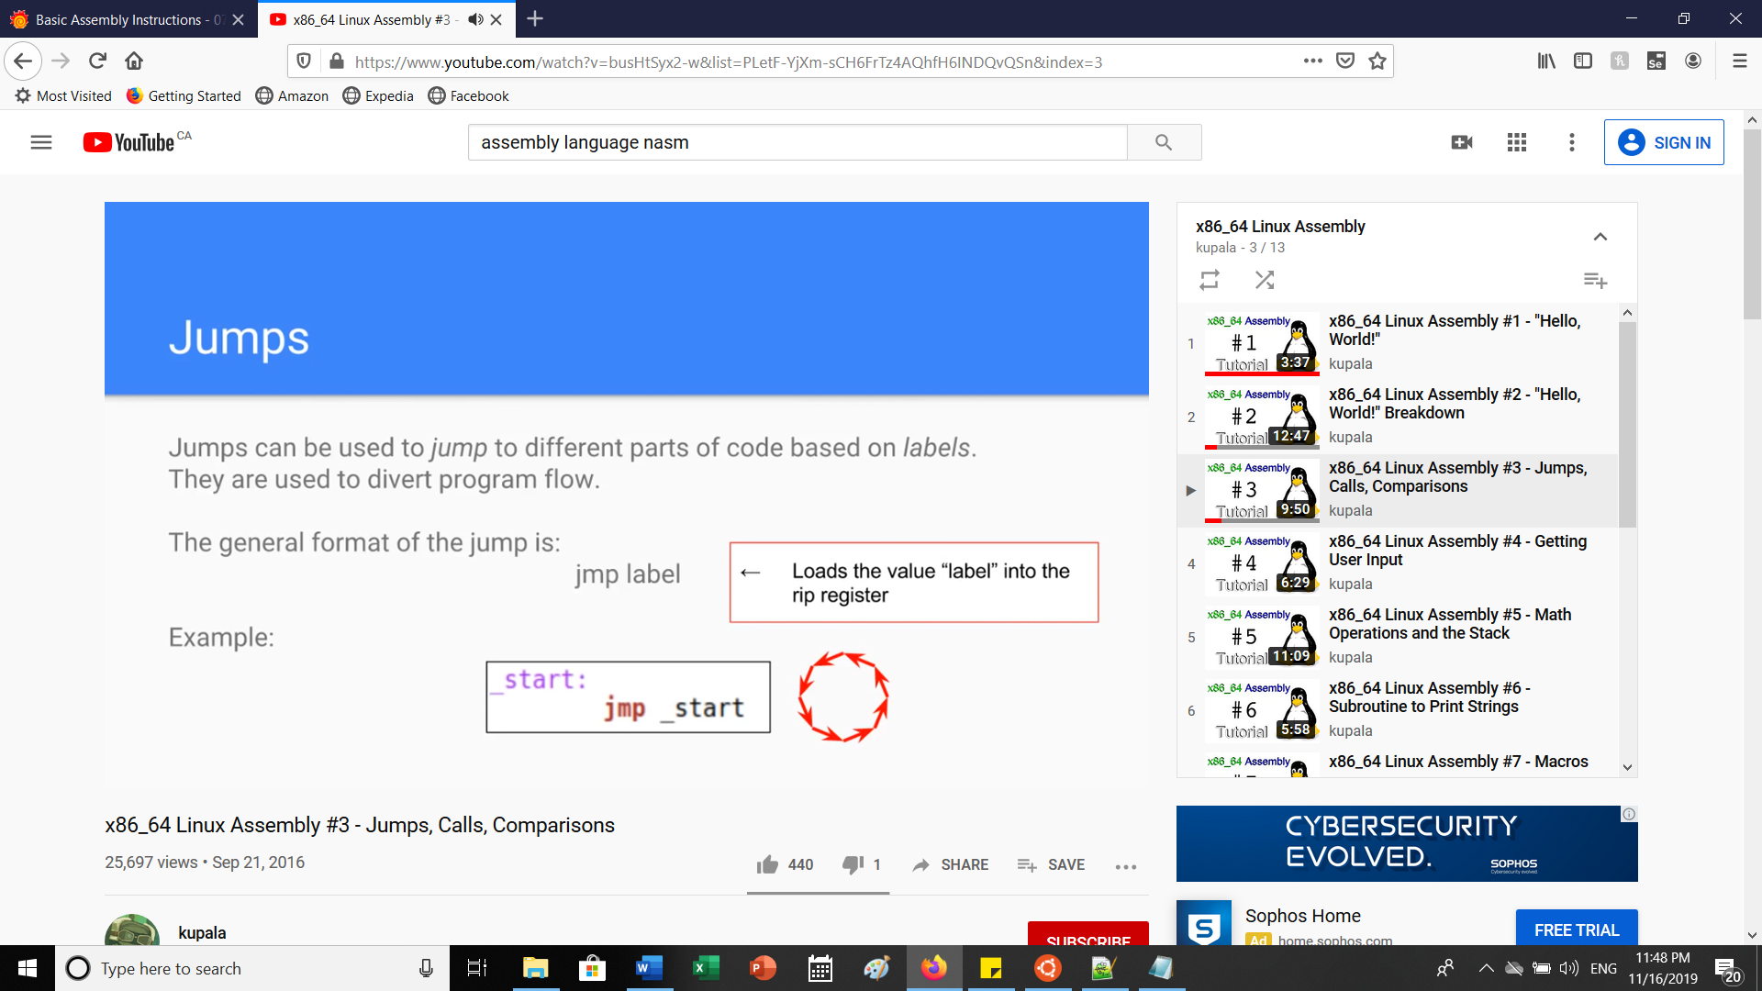

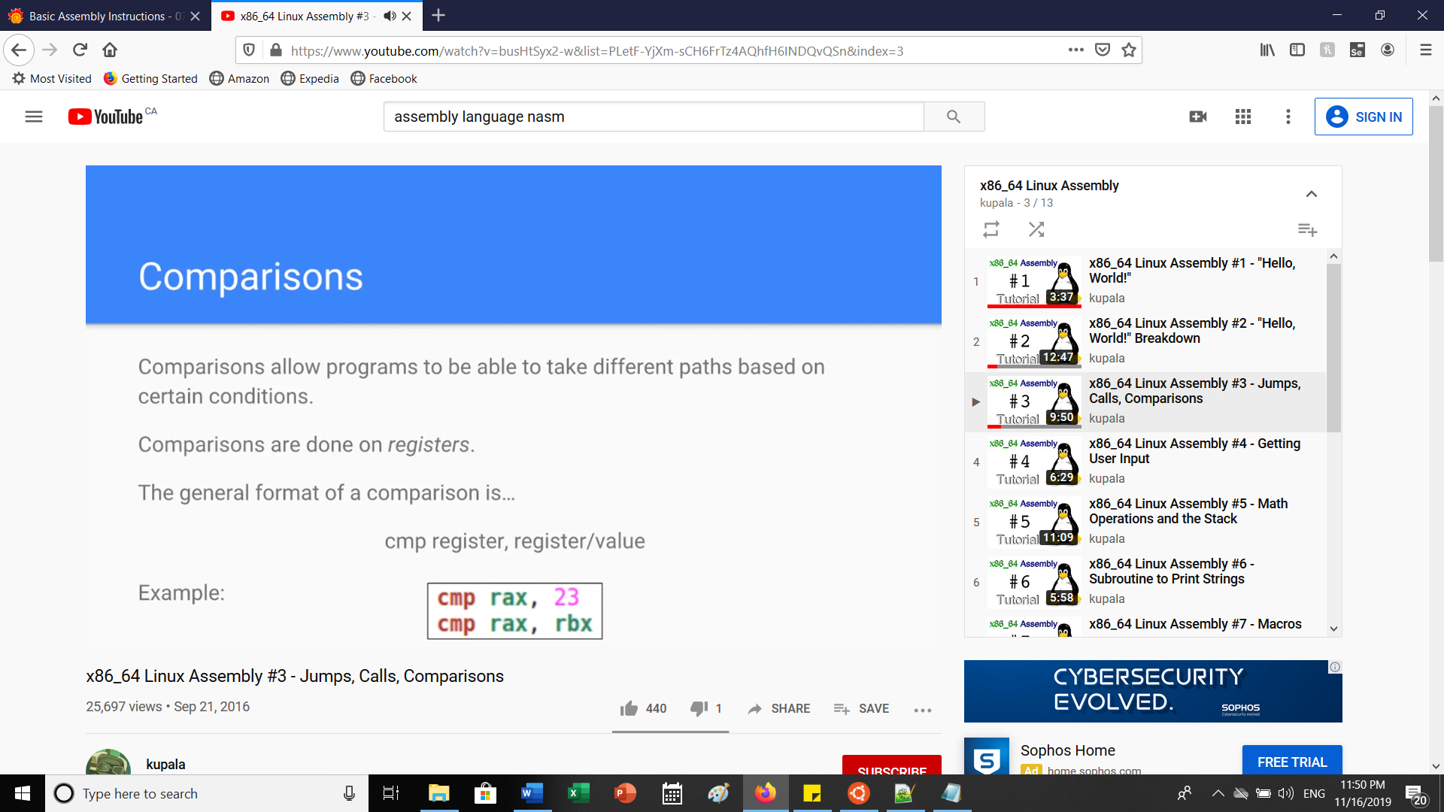

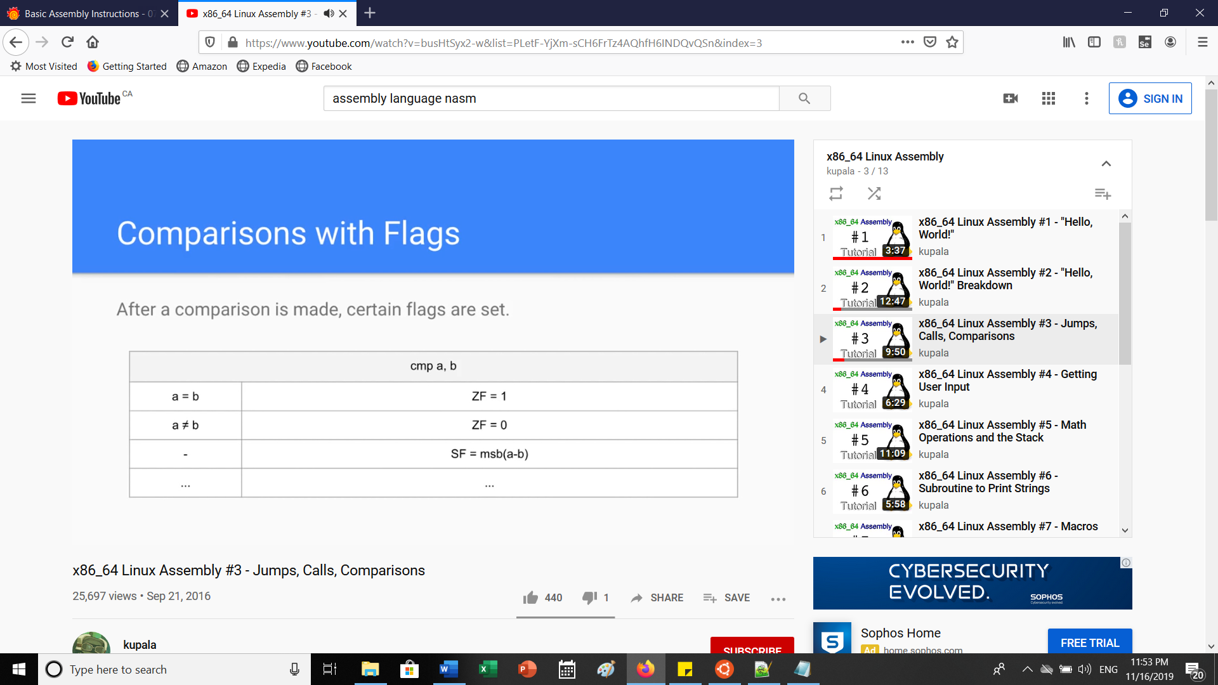

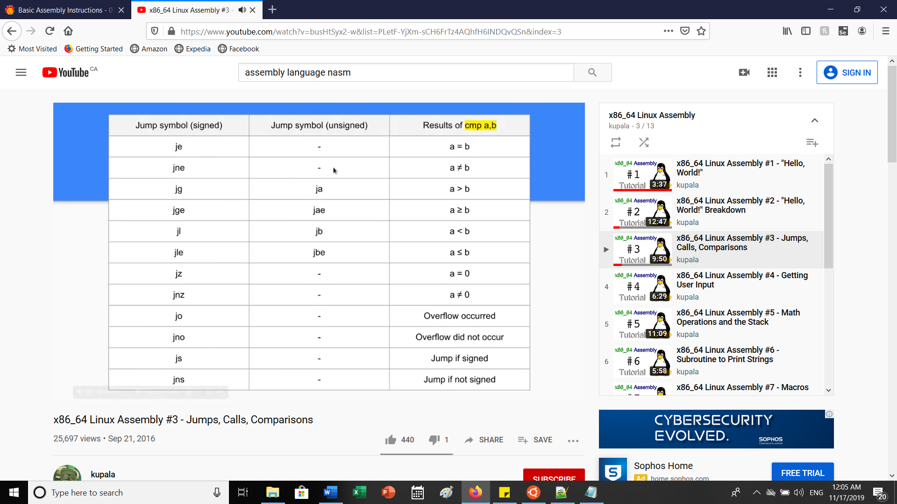

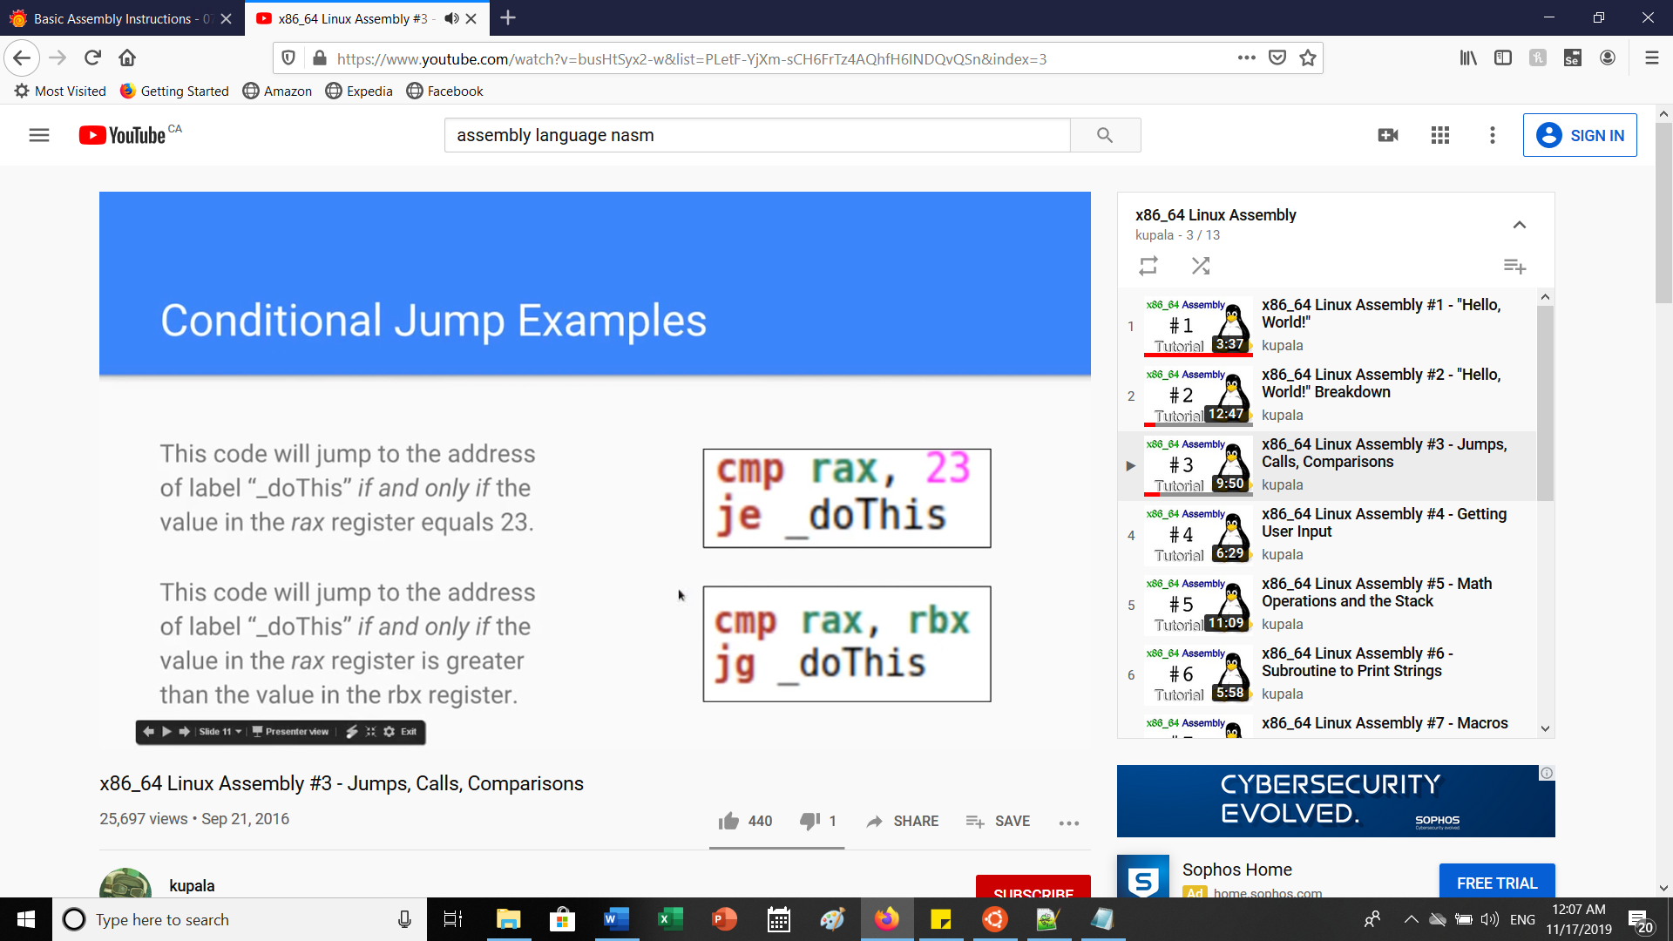

**Pointers and registers movements:**

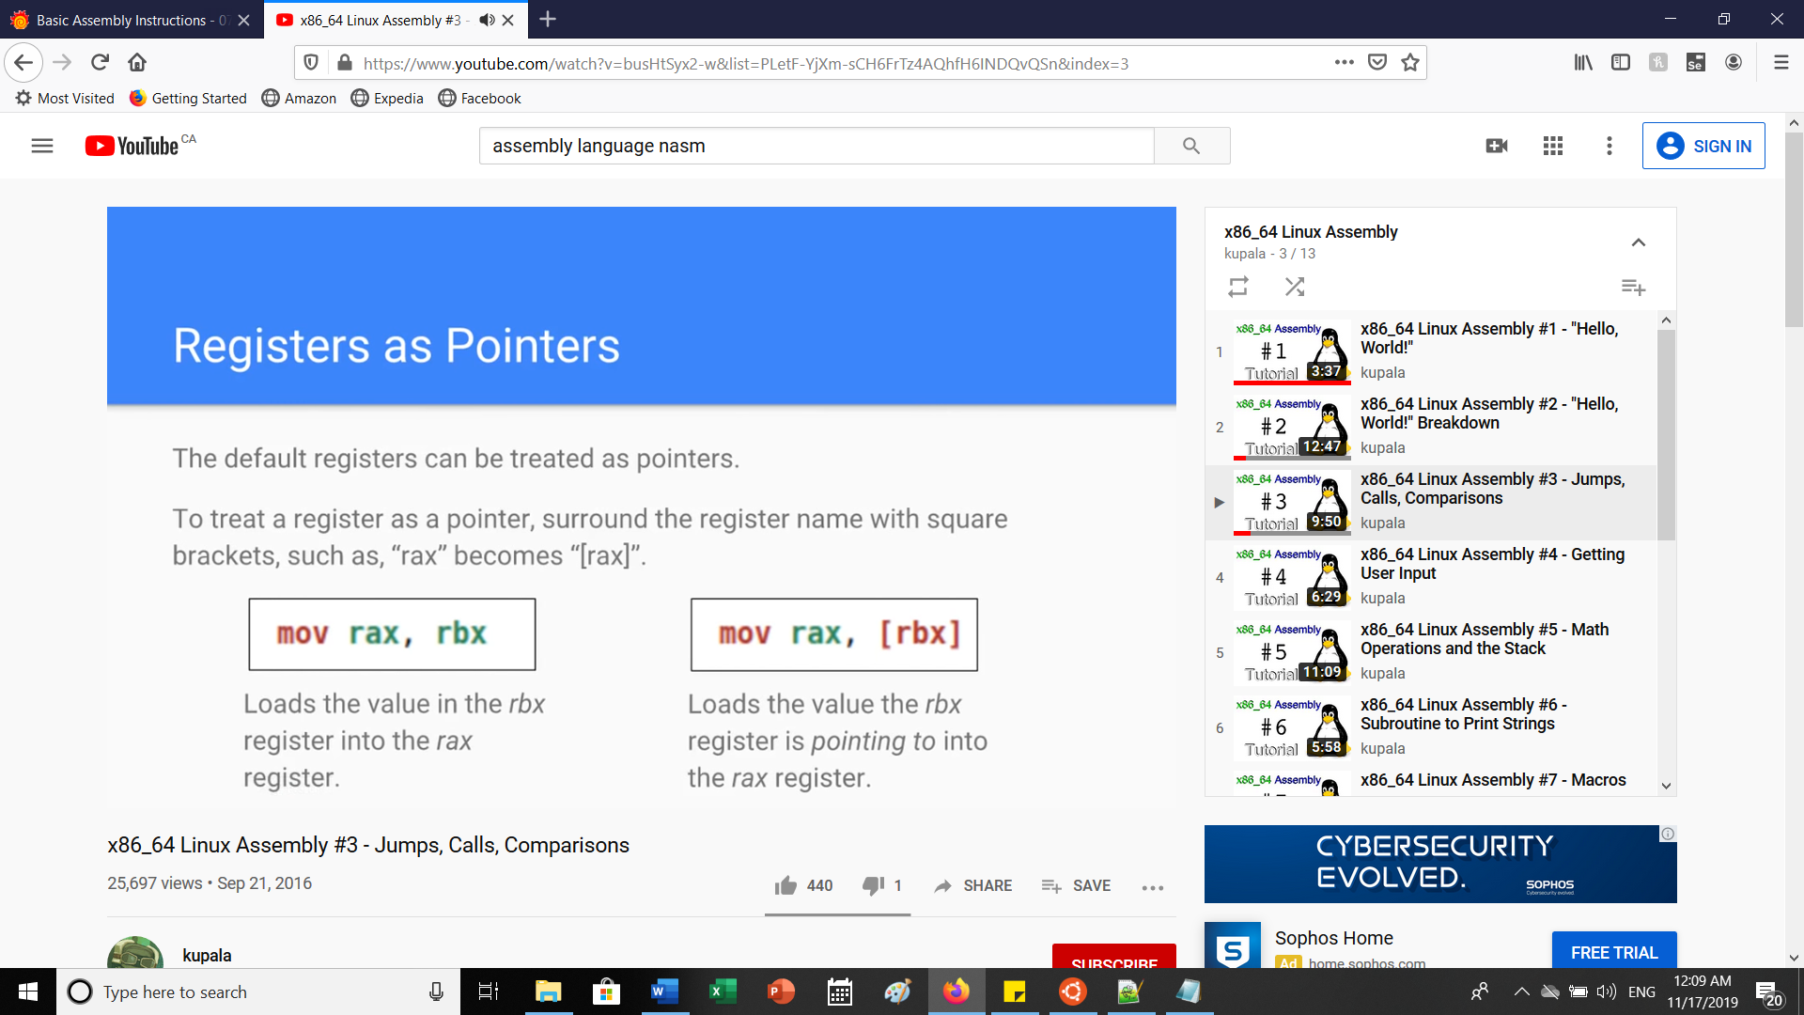

**Subroutines/Function calls:**

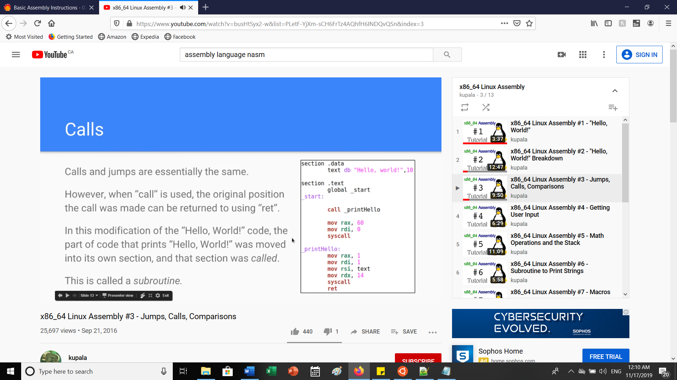

**Part C: Math Operations**

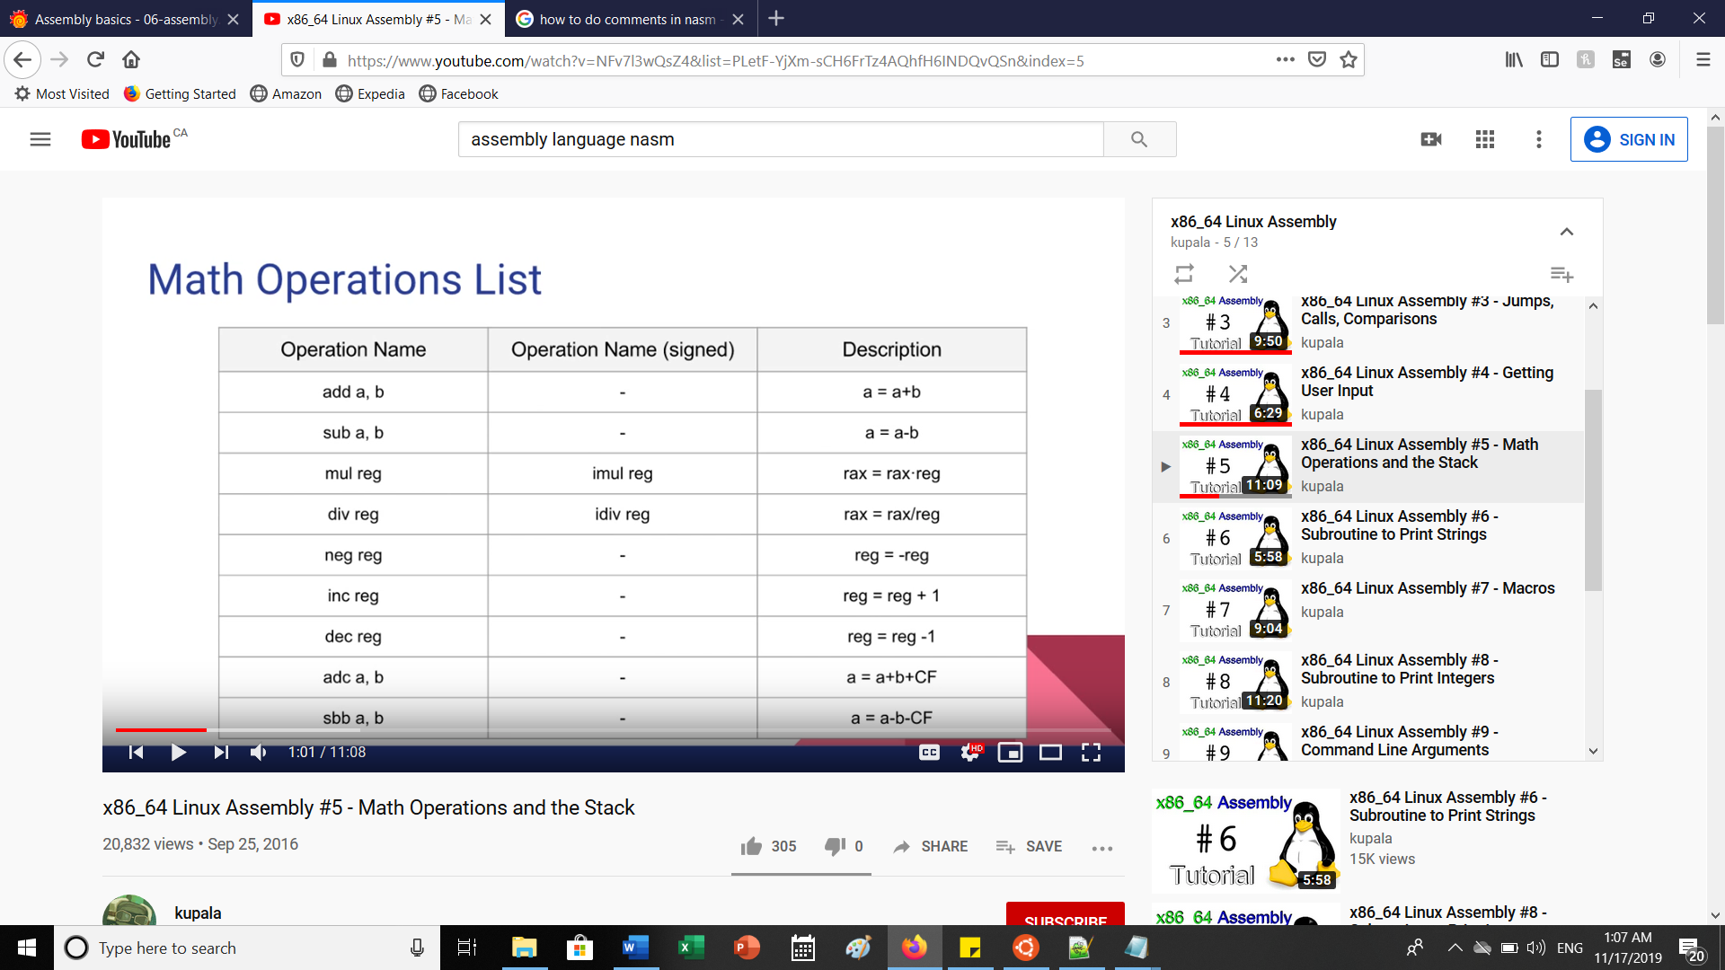

**Doing Addition operations and overwriting Least Sig bytes AND printing:**

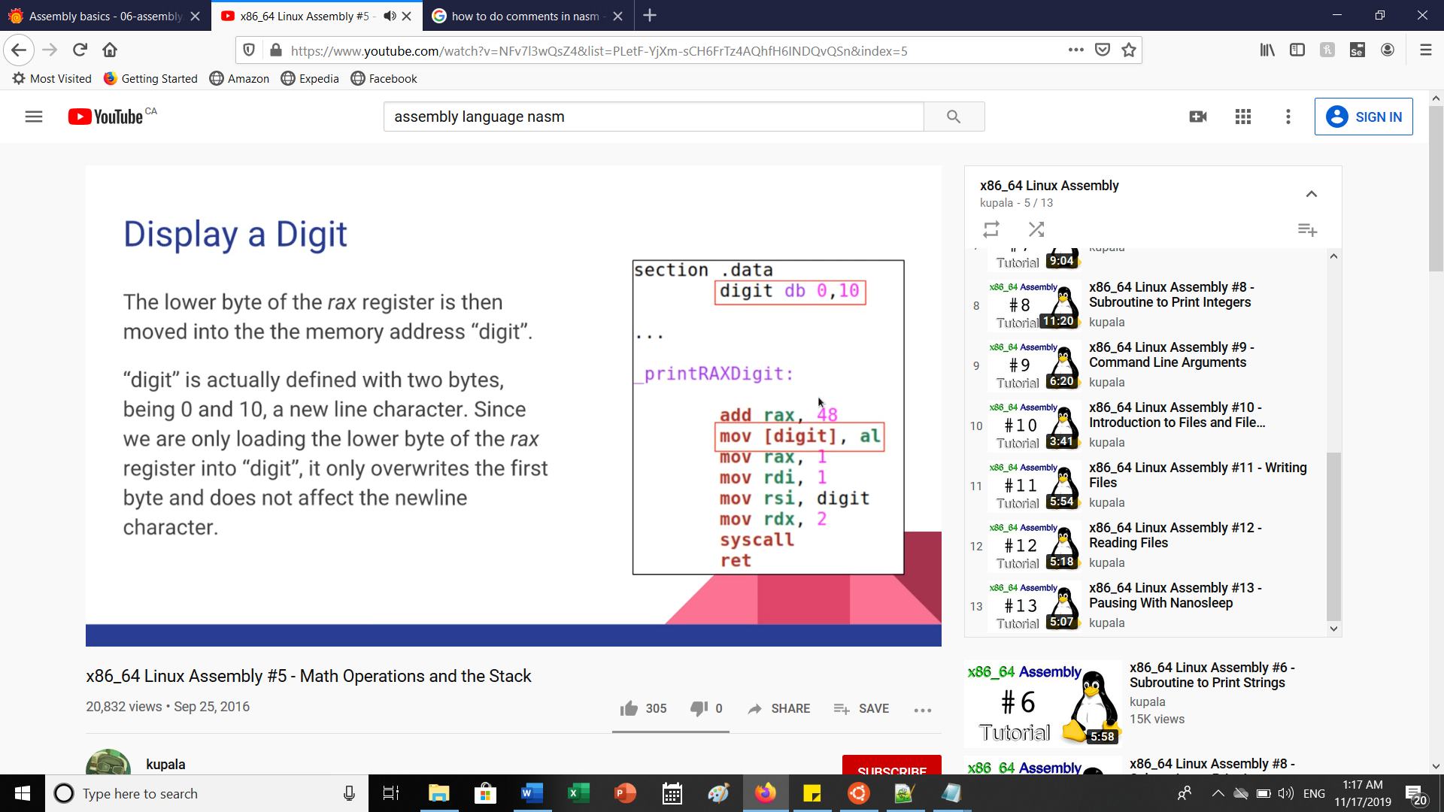

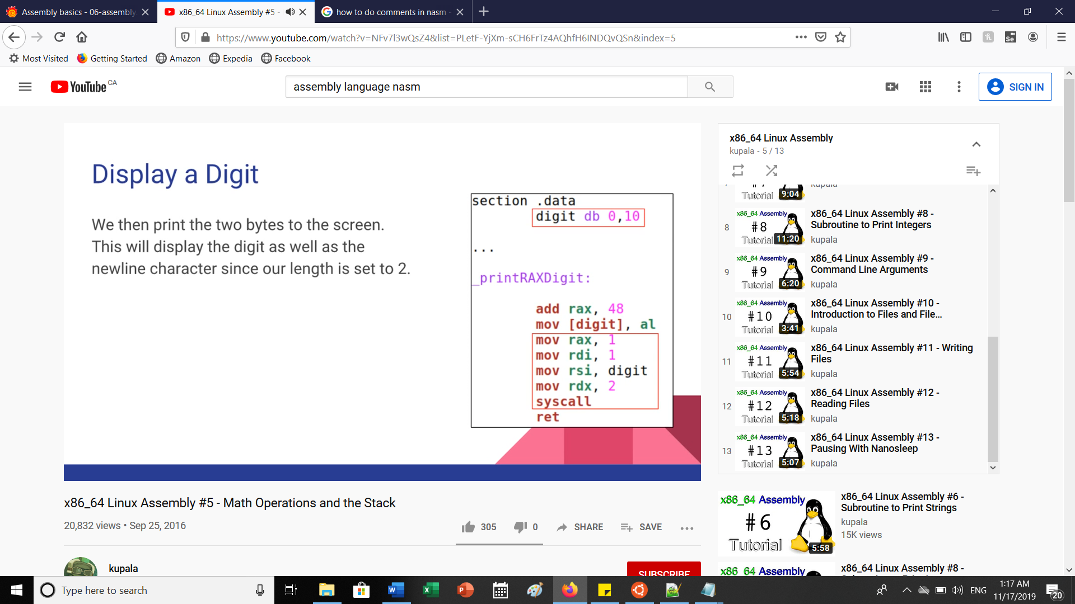

Newline character has ASCII value of 10. First bit of ‘digit’ label has value of 0 which represents something in ASCII code. We then add 48 to rax register which initially has 0. This means rax is now equivalent to 0 since the number 48 is ‘0’ in ASCII. We move the 48 to the lower byte of digit so that it only replace the 0 in the digit bytes. We can use this simple subroutine to print ASCII numbers from 0 – 9

By setting ‘rax’ to a certain value before calling the subroutine. The subroutine then adds 48 to the current rax value and then displays it to the screen!

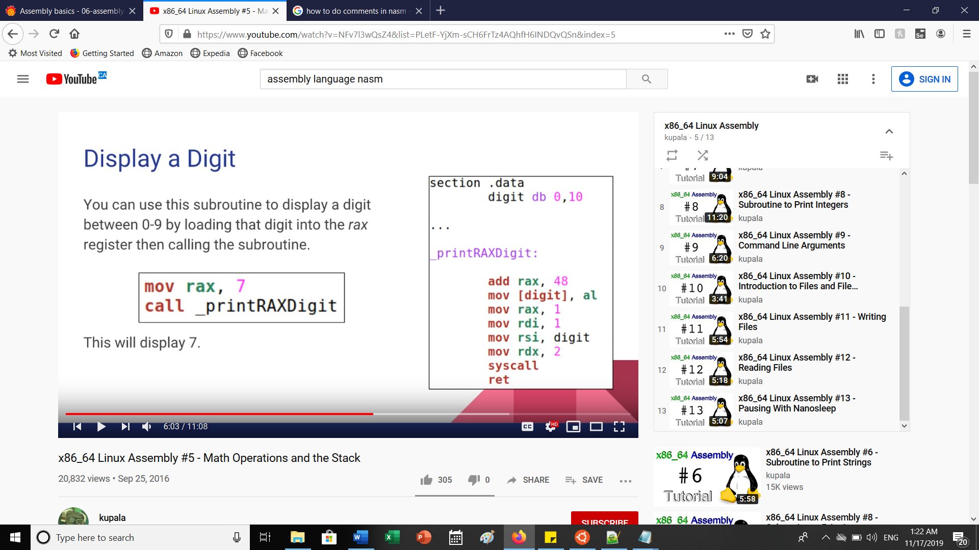

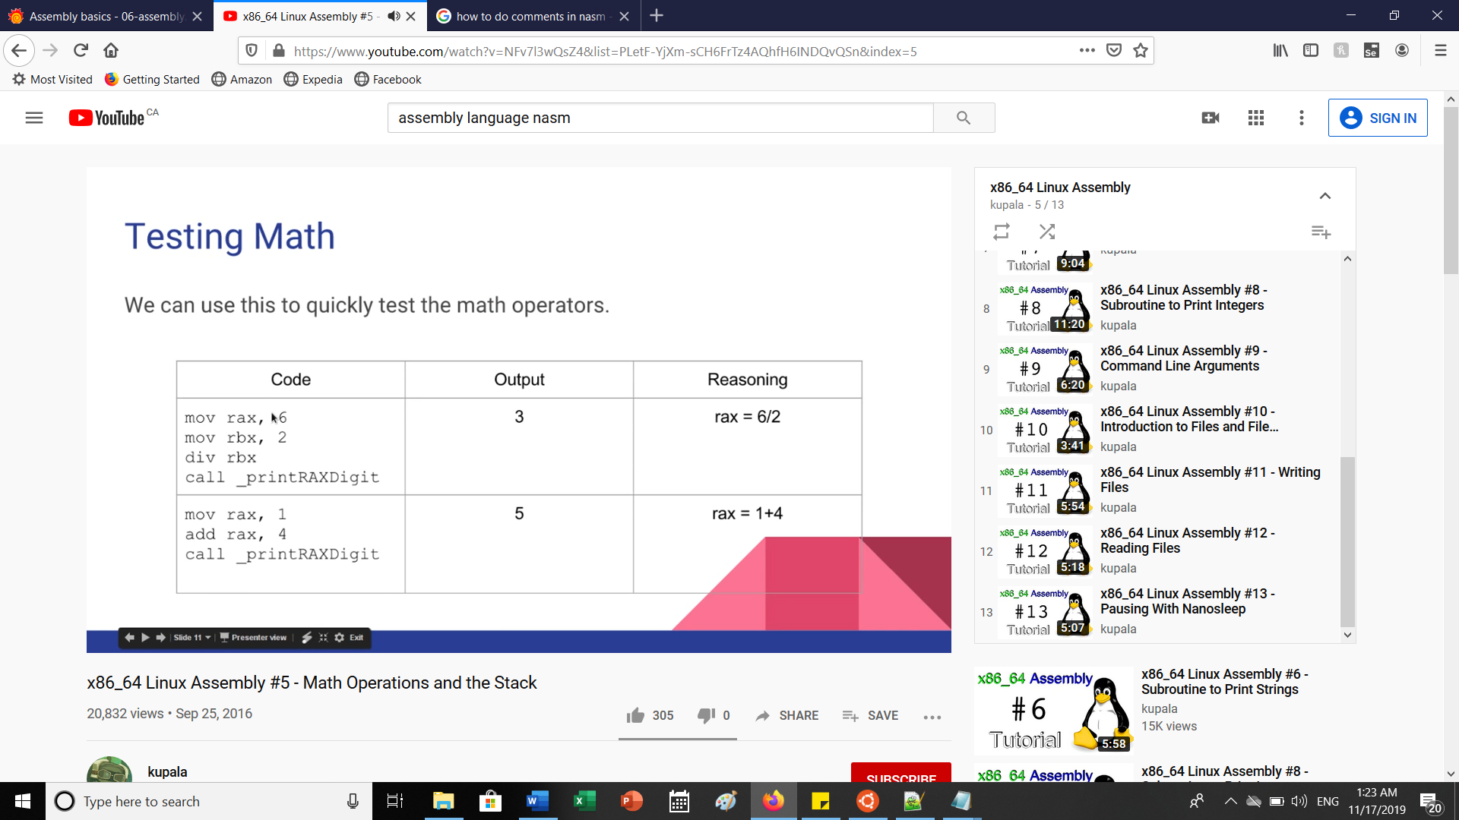

* *When doing division for rax, the rdx and rax registers combine to form a 128 bit register which can skew results. This is why before doing anything with division when you don’t want to set a value to rdx, set rdx to 0 before the division using ‘mov rdx, 0’. In addition, rdx also holds the remainder when doing integer division*

**PART C: Continued (INTRO TO STACKS)**

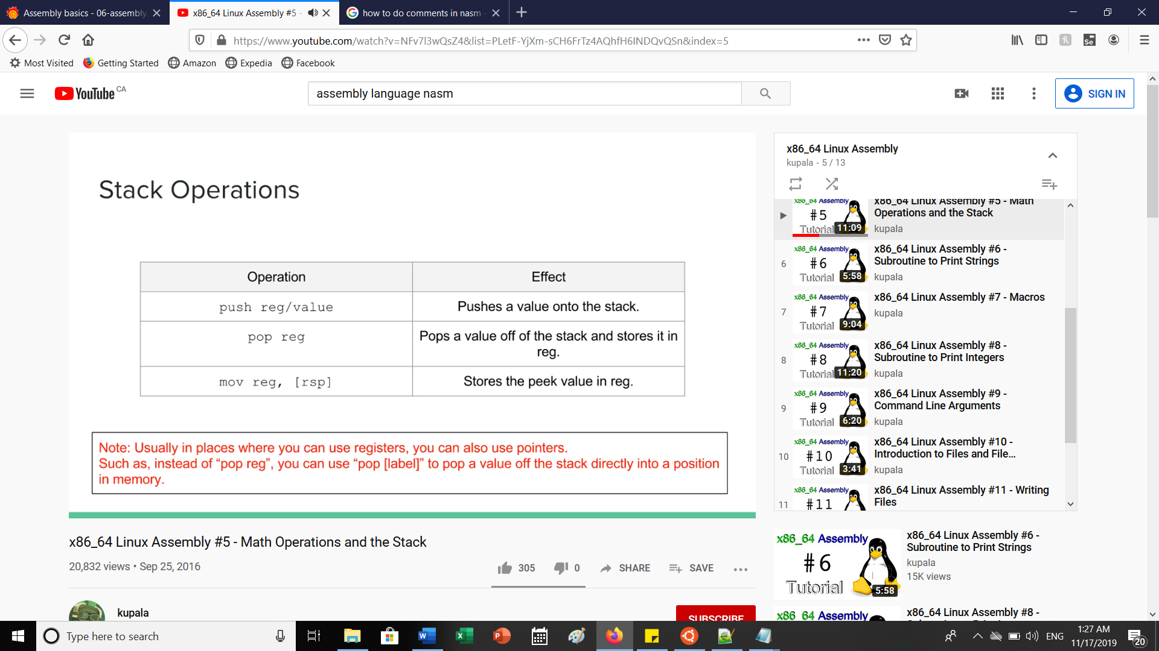

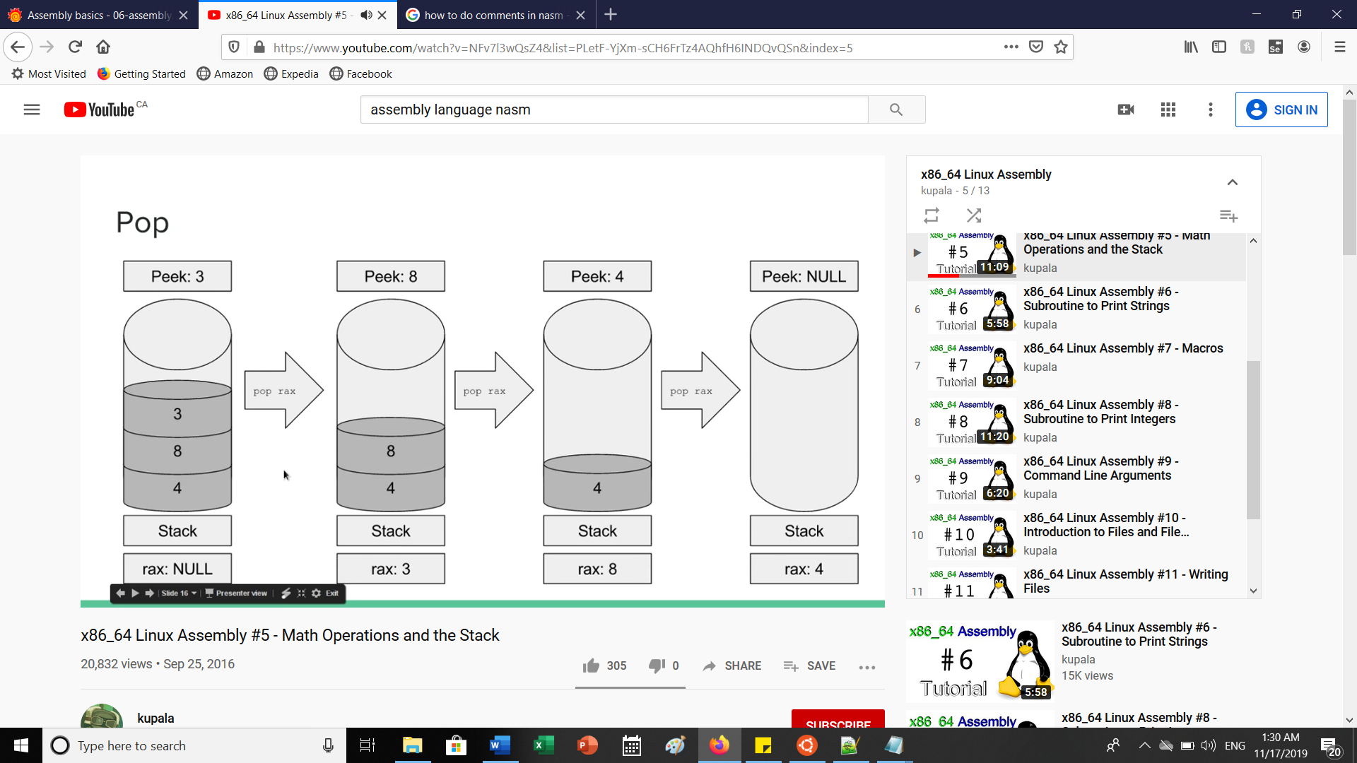

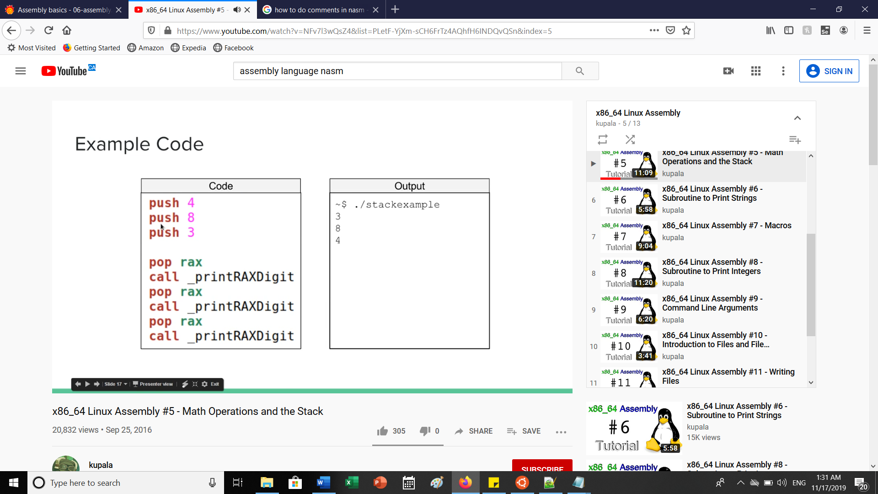

**PART D: SUBROUTINE TO PRINT STRINGS**

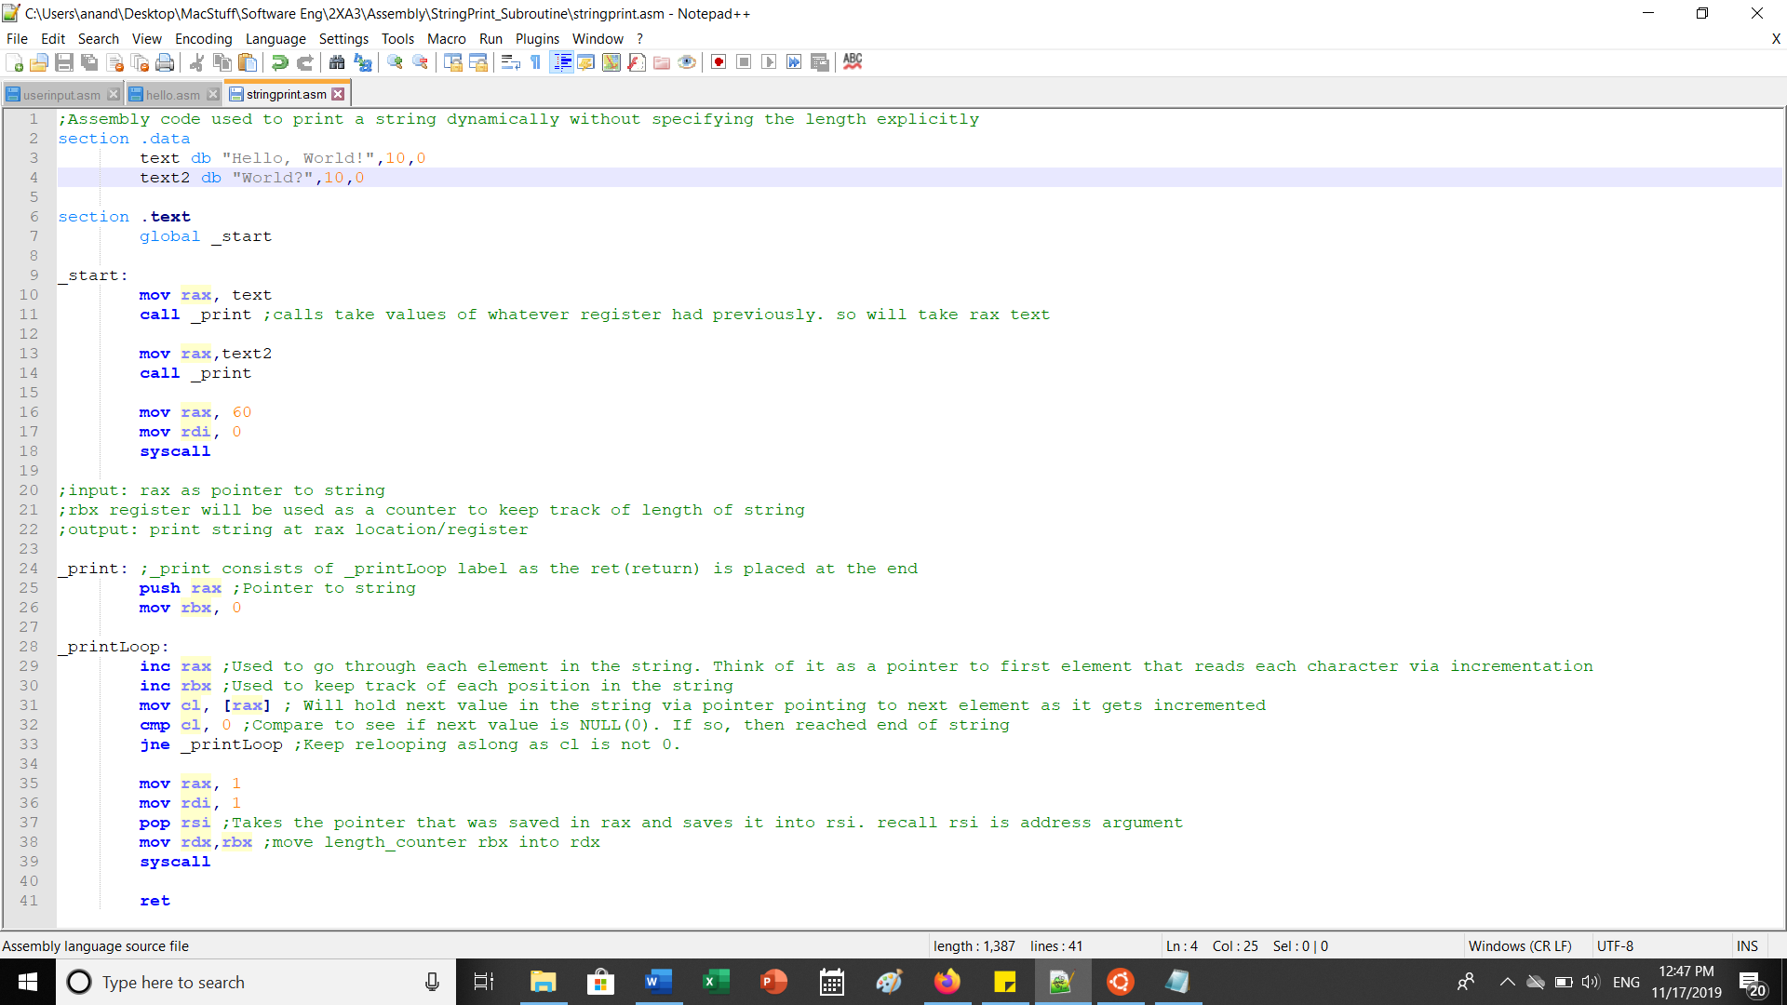

**PART E: MACROS:**

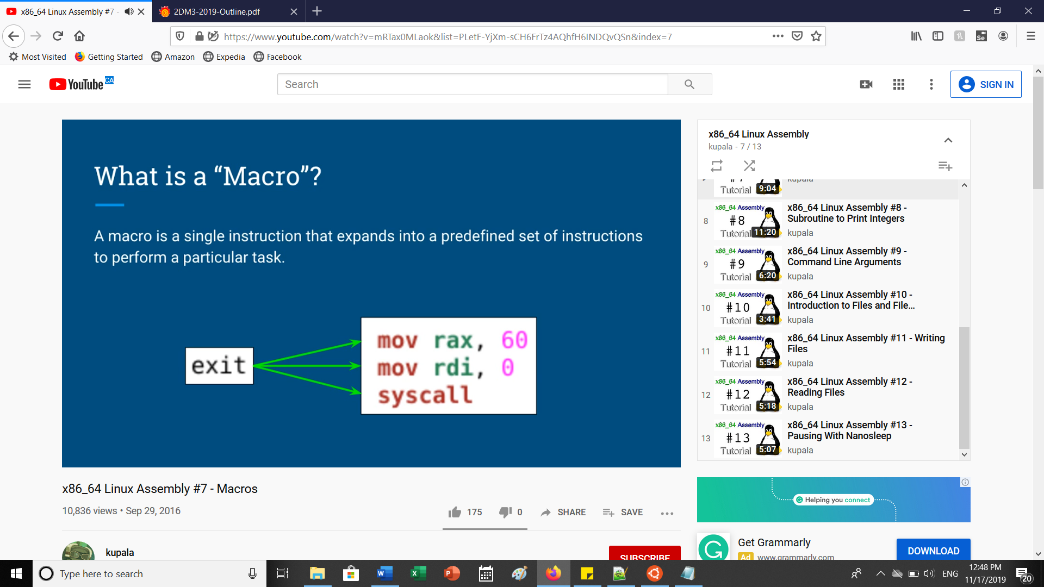

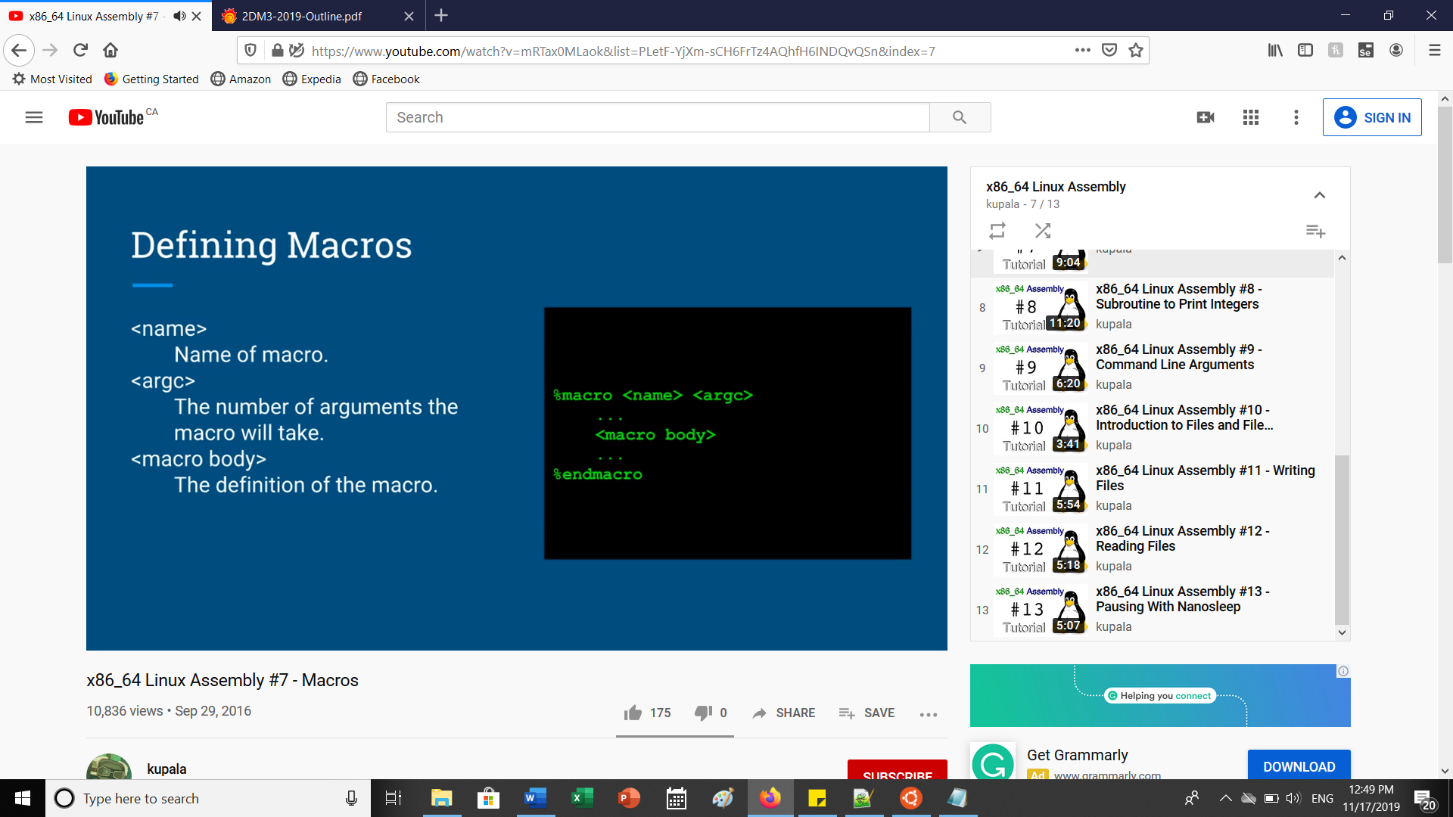

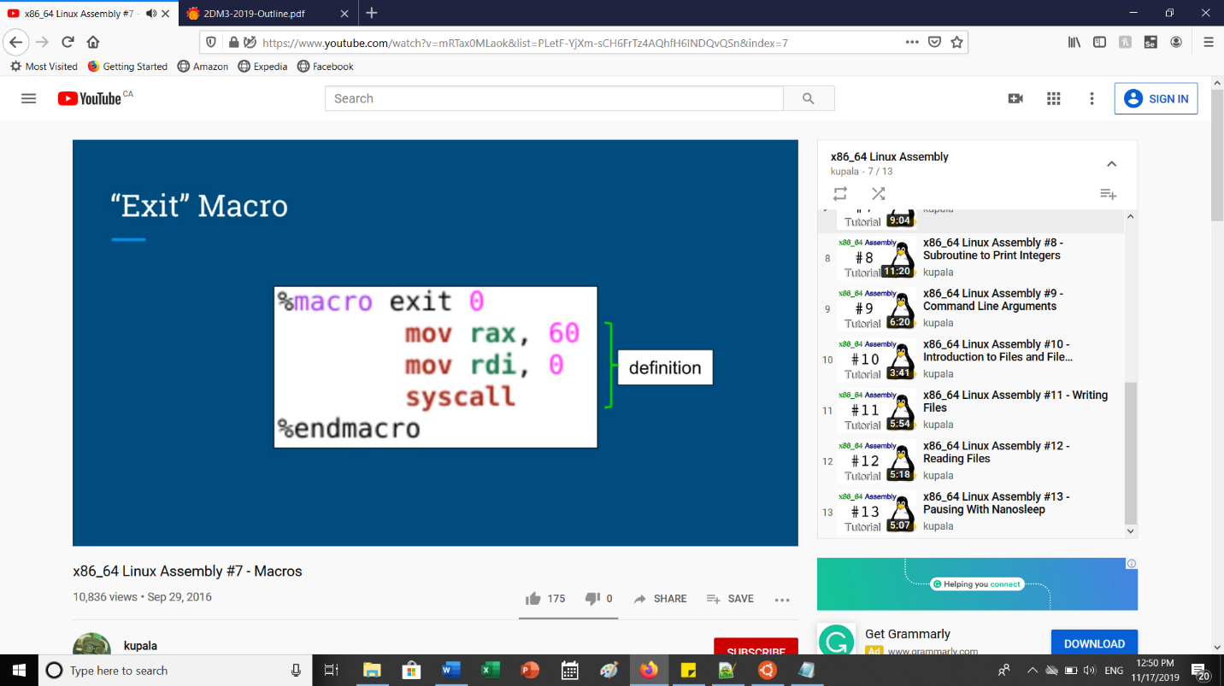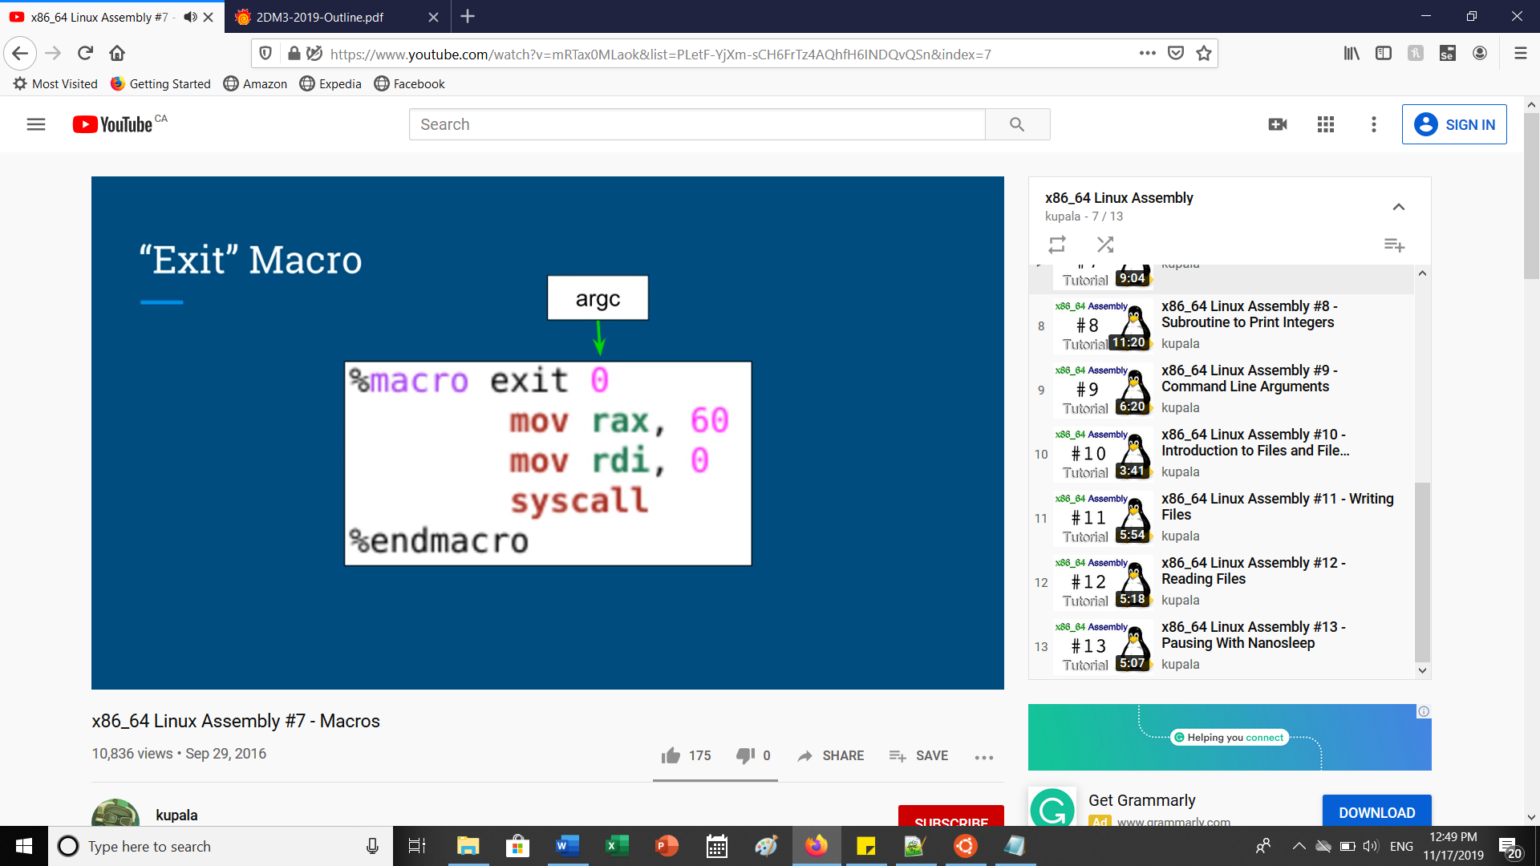

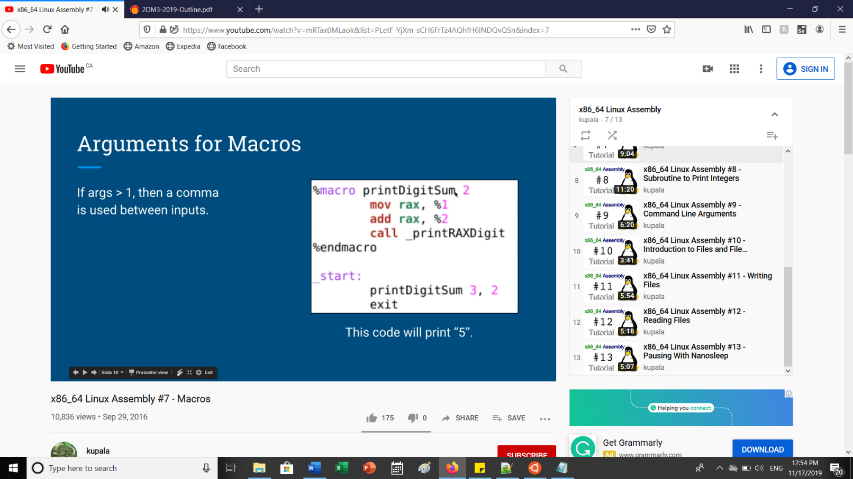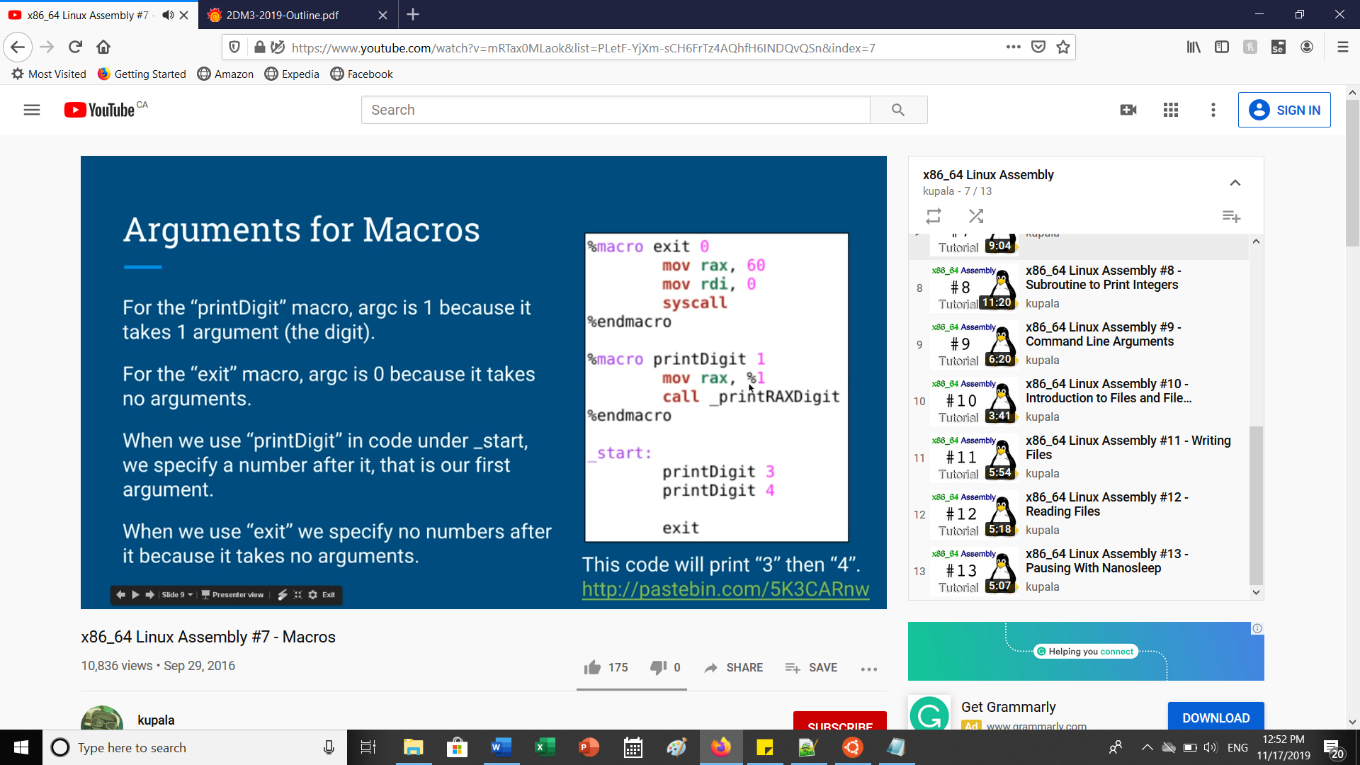

Duplicate label/Redefined label error:

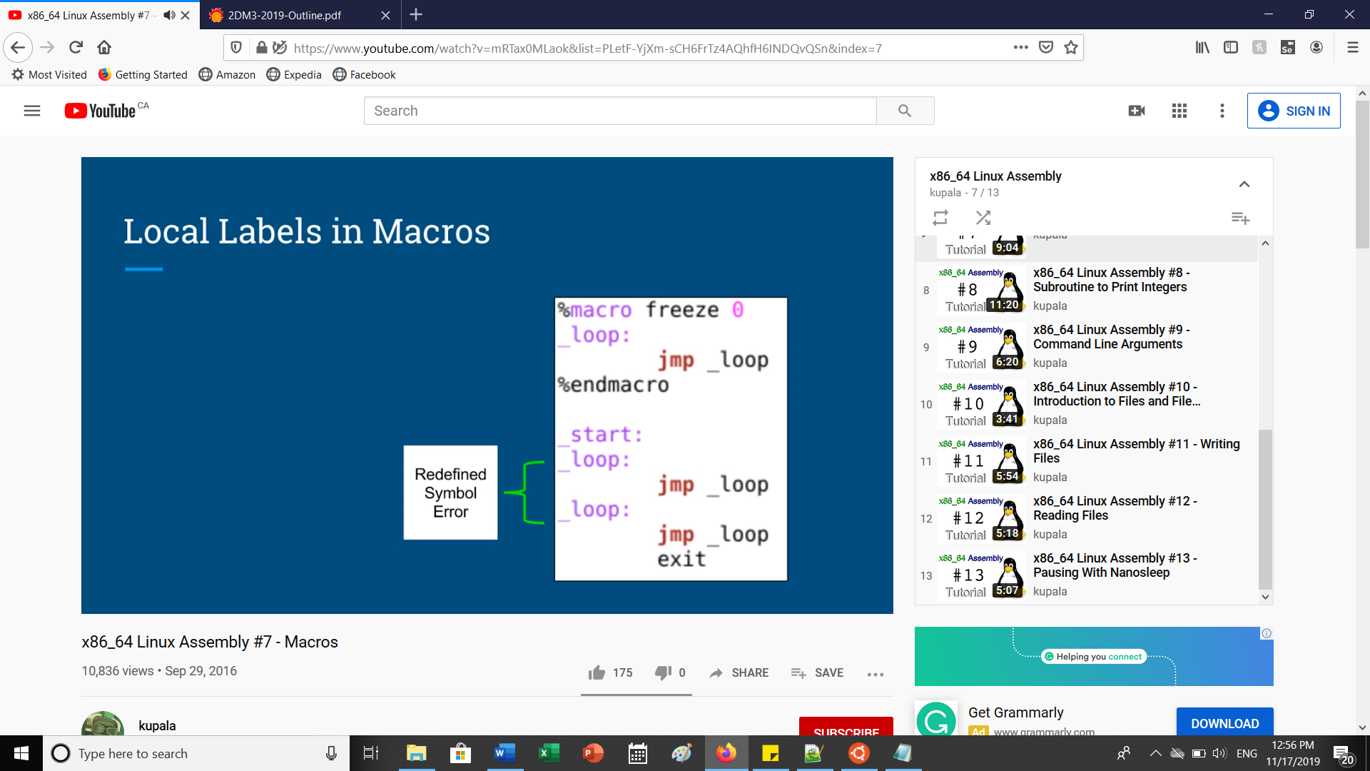

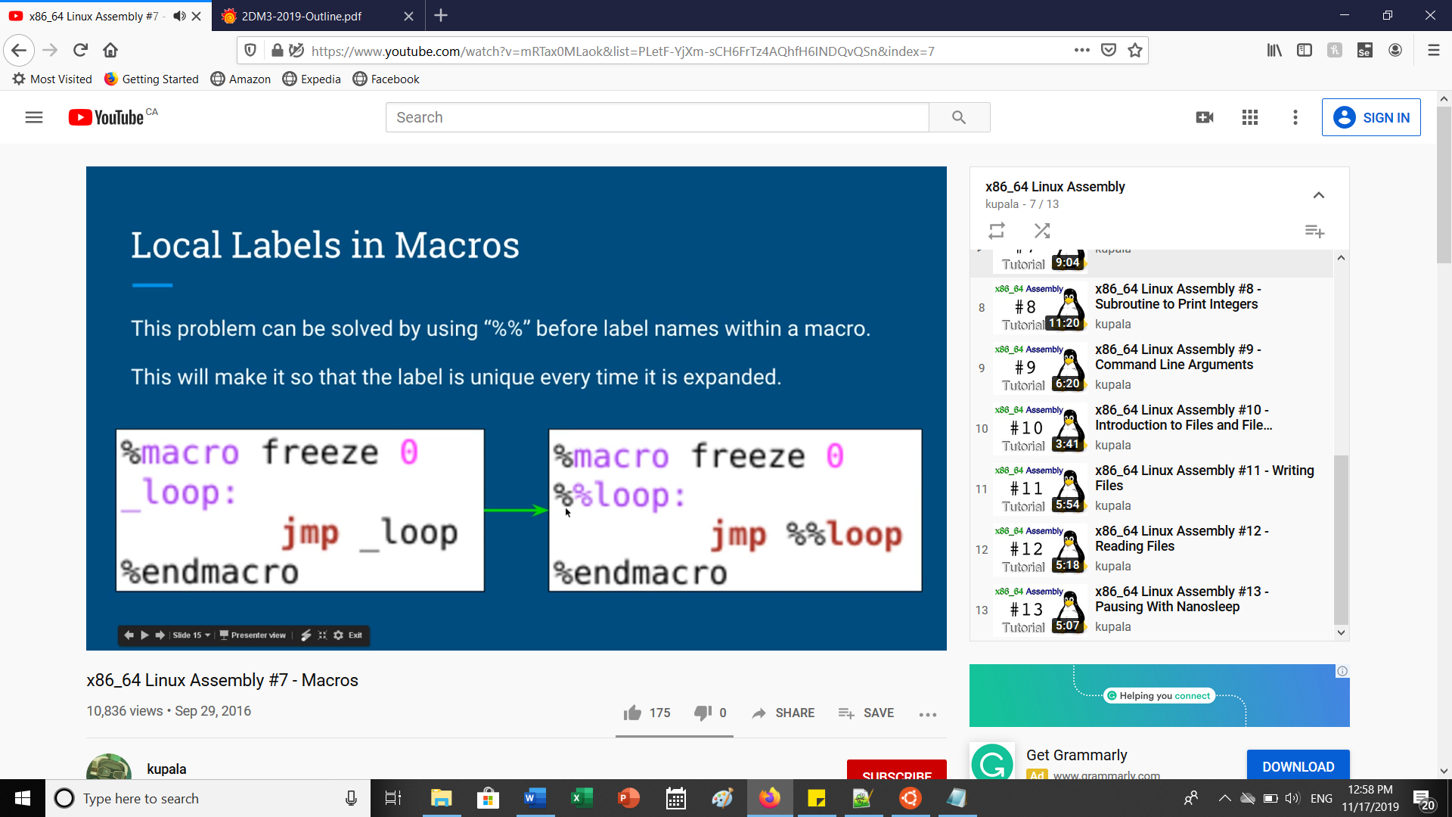

**In general: Macros can be useful for readability:**

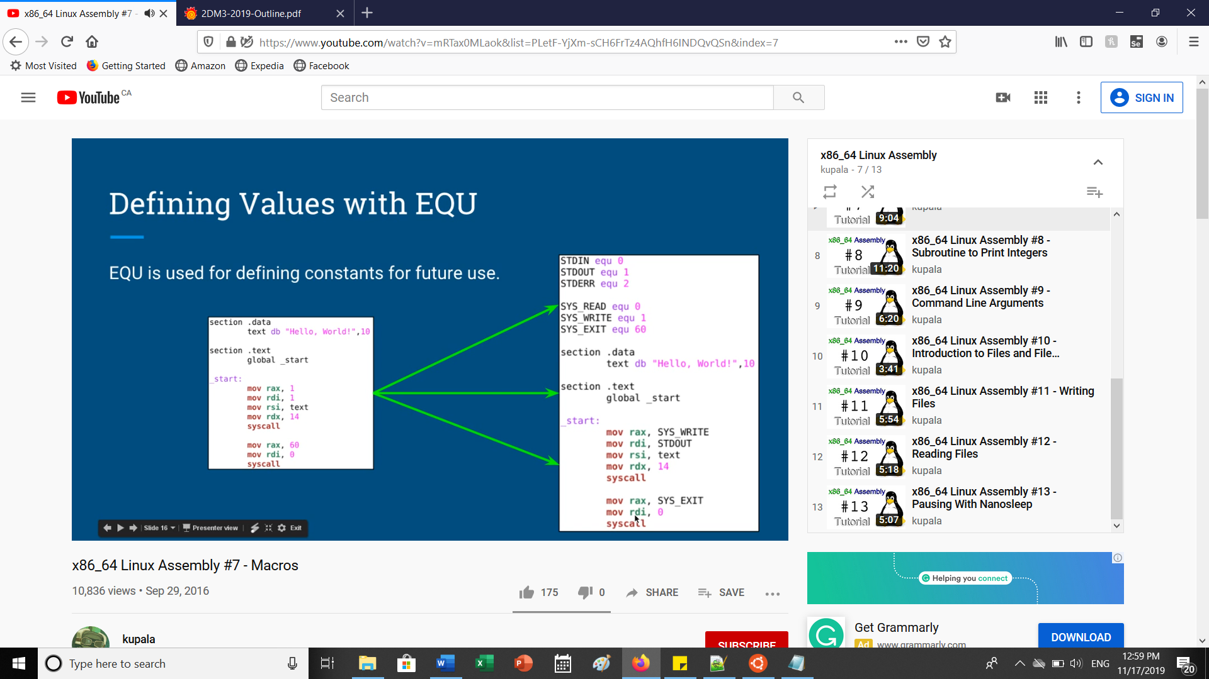

**INCLUDE EXTERNAL FILES:**

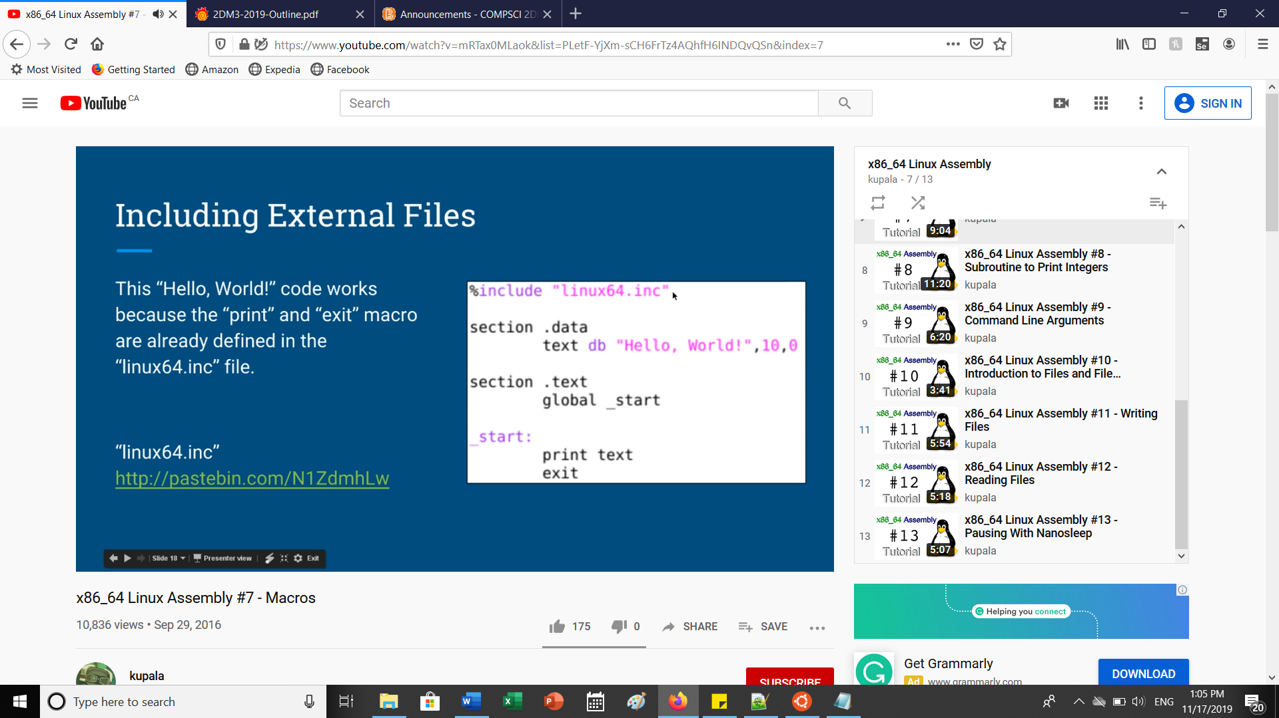

**PART E: SUBROUTINE TO PRINT INTEGERS**

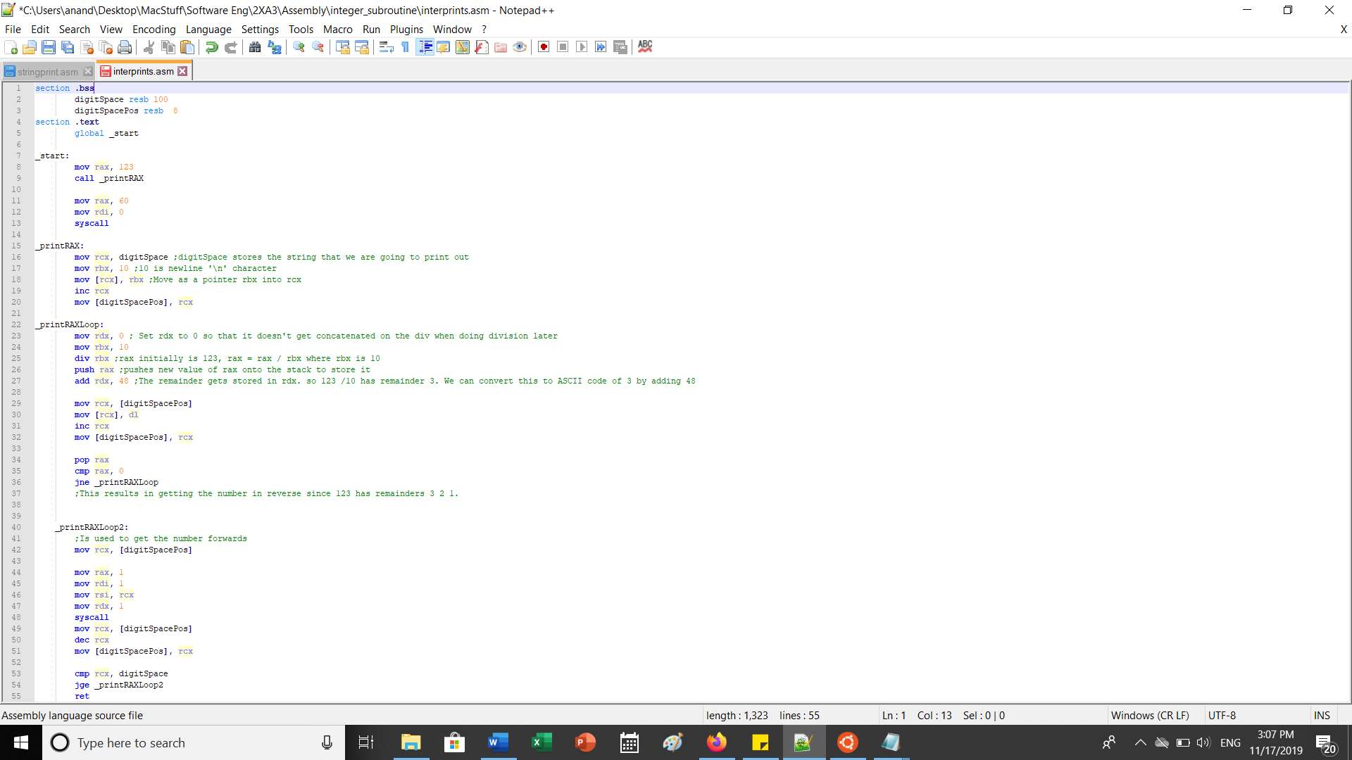

**PART F: COMMAND LINE ARGUMENTS:**

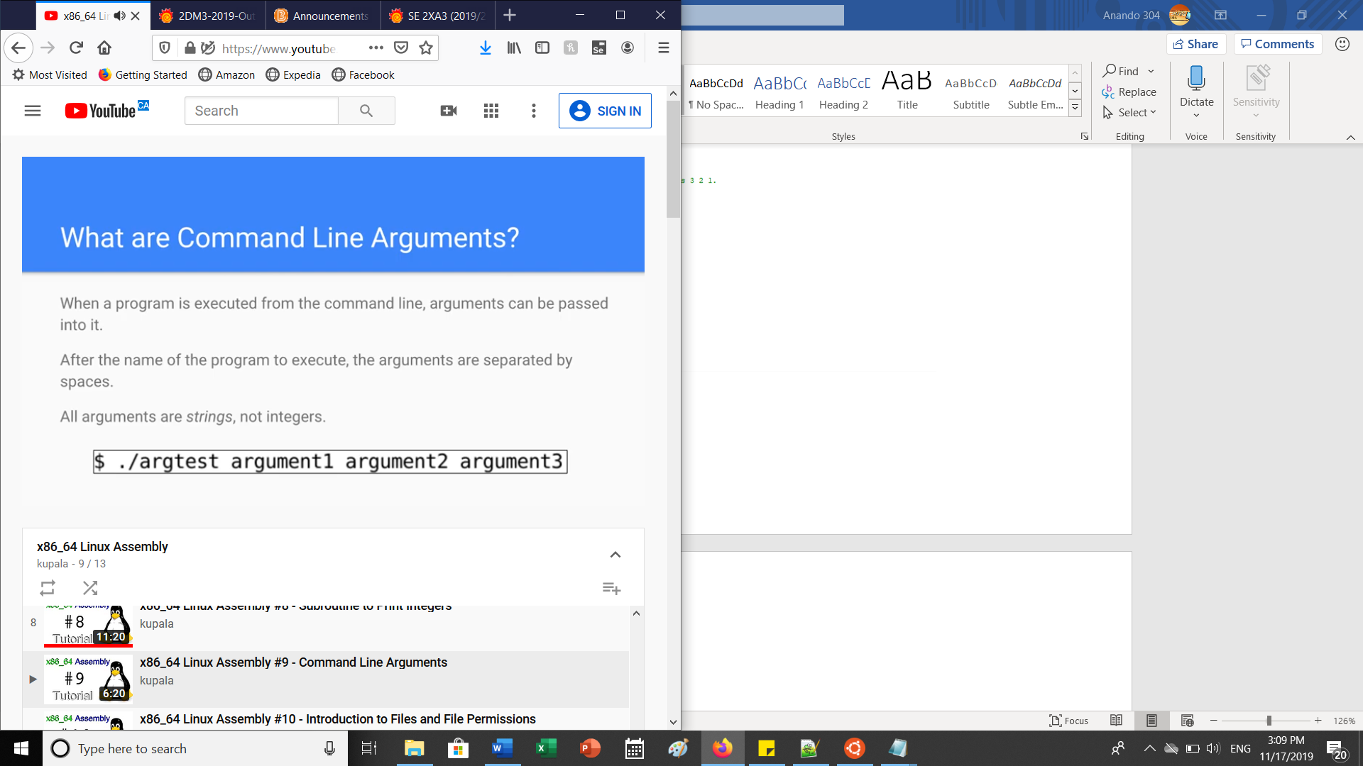

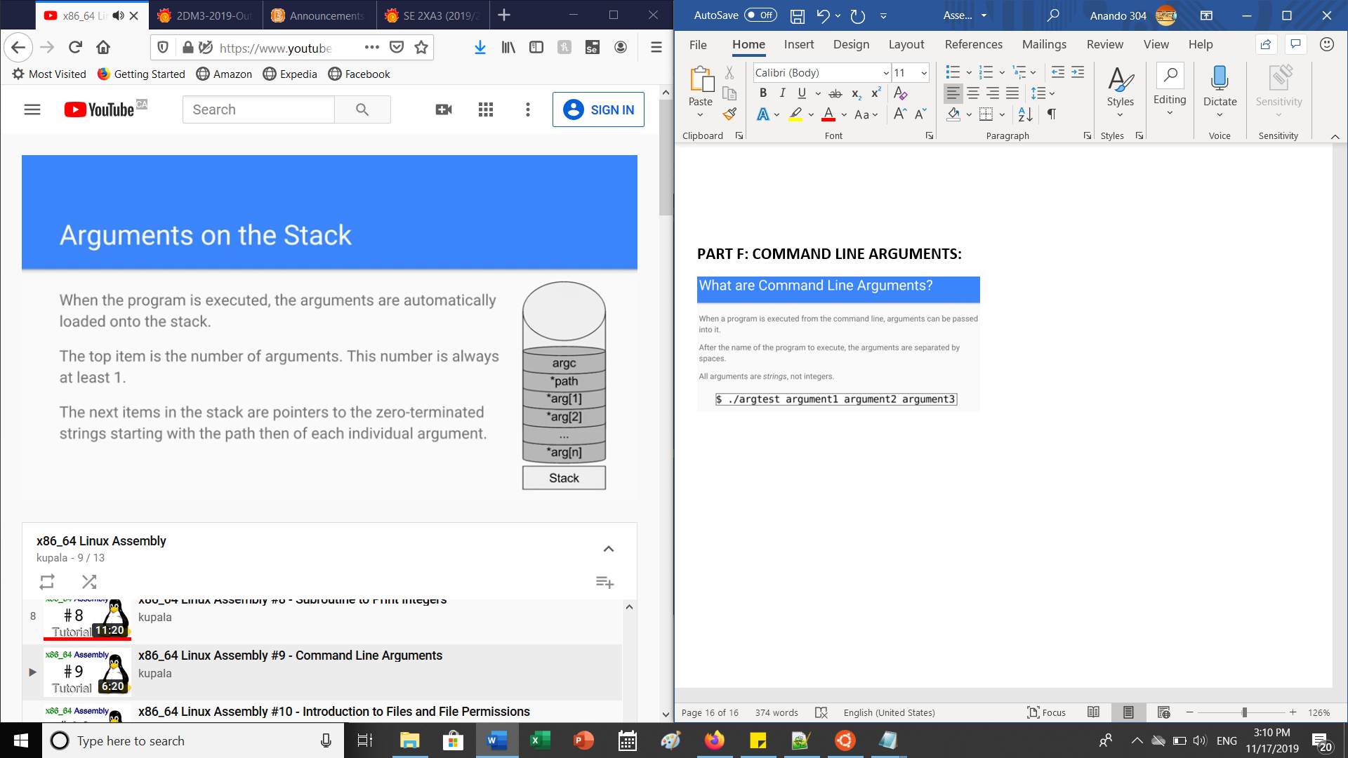

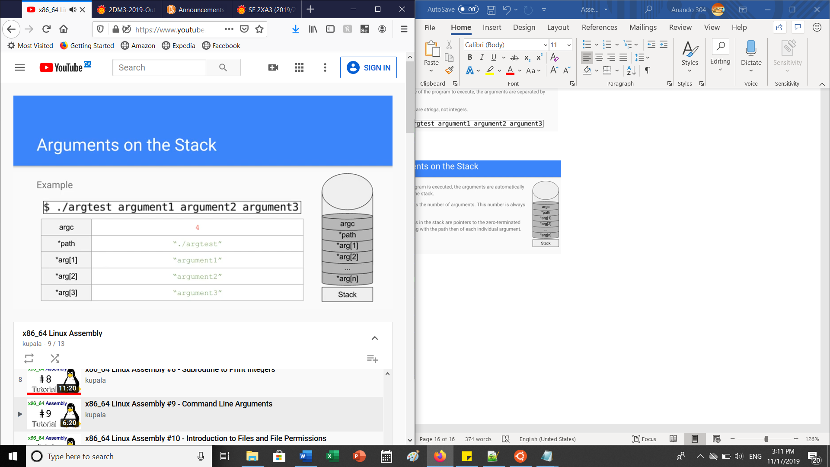

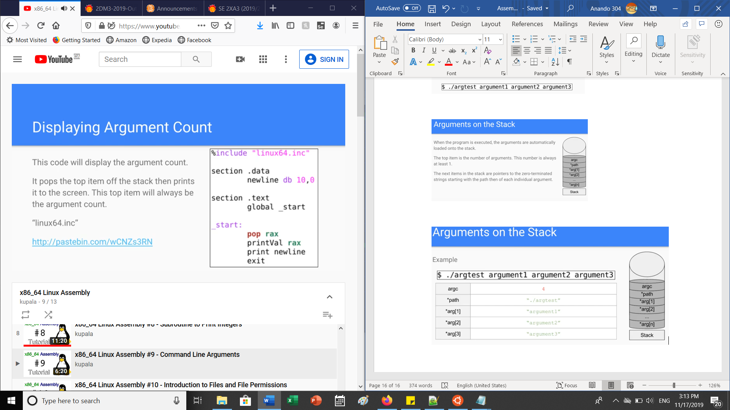

**PART G: WRITING FILES:**

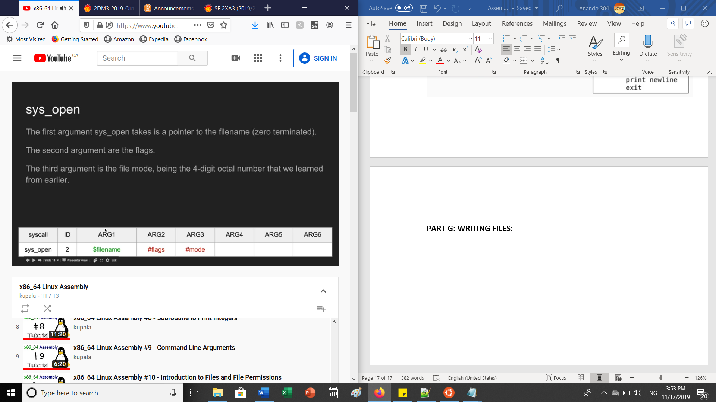

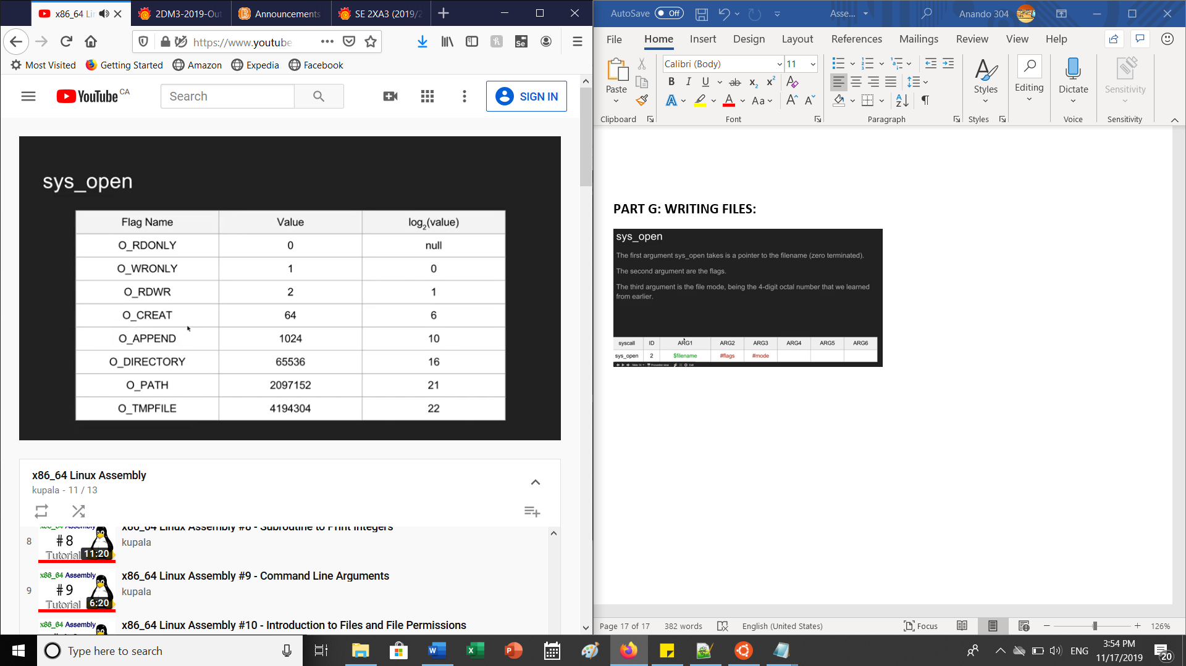

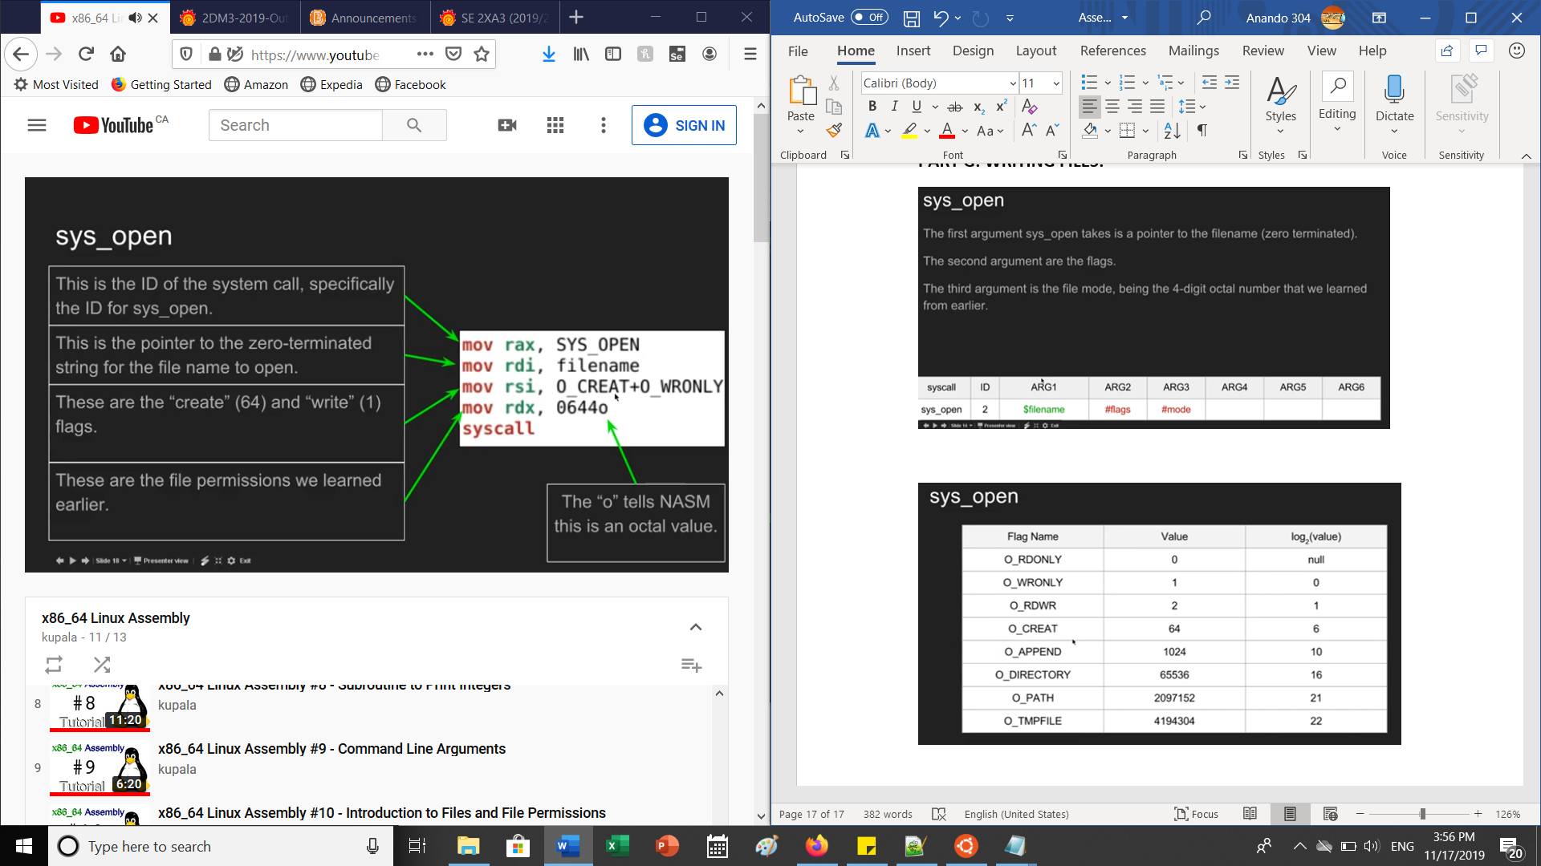 SYS_OPEN = 0

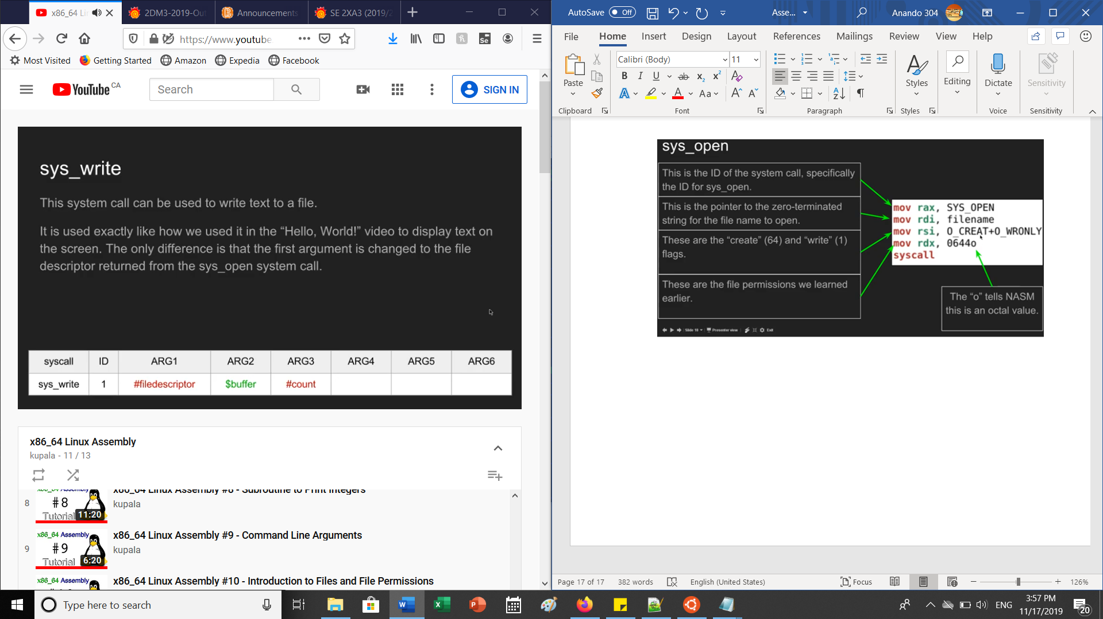

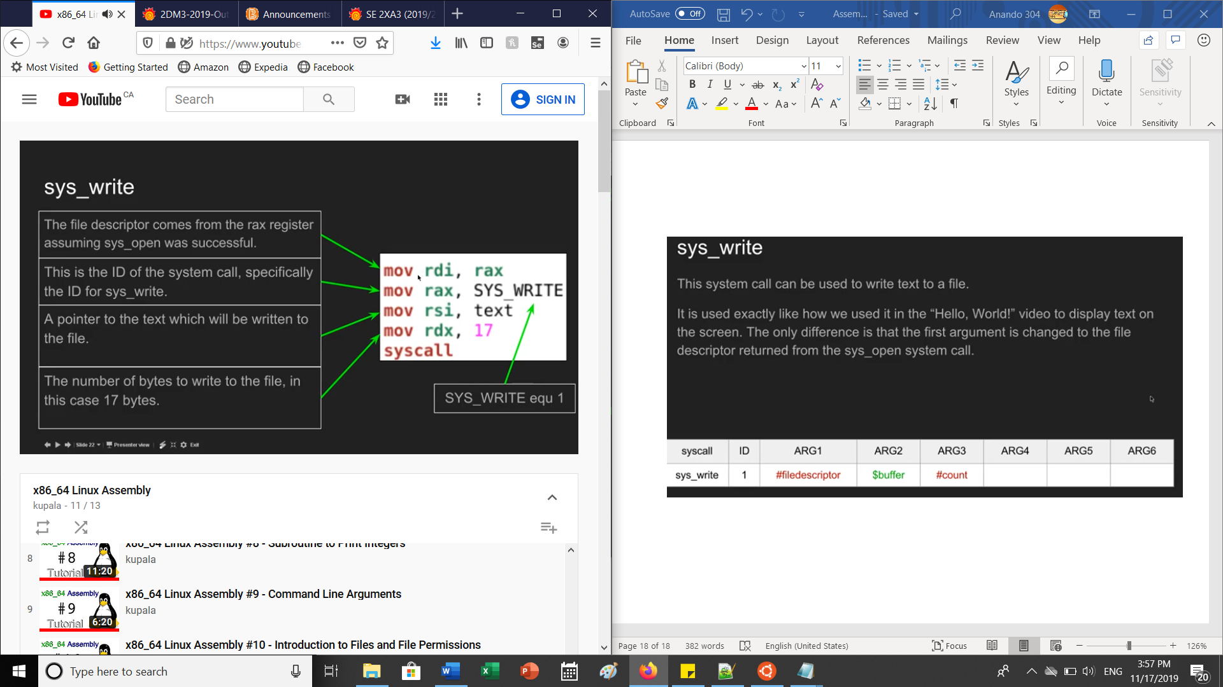 SYS_WRITE = 1

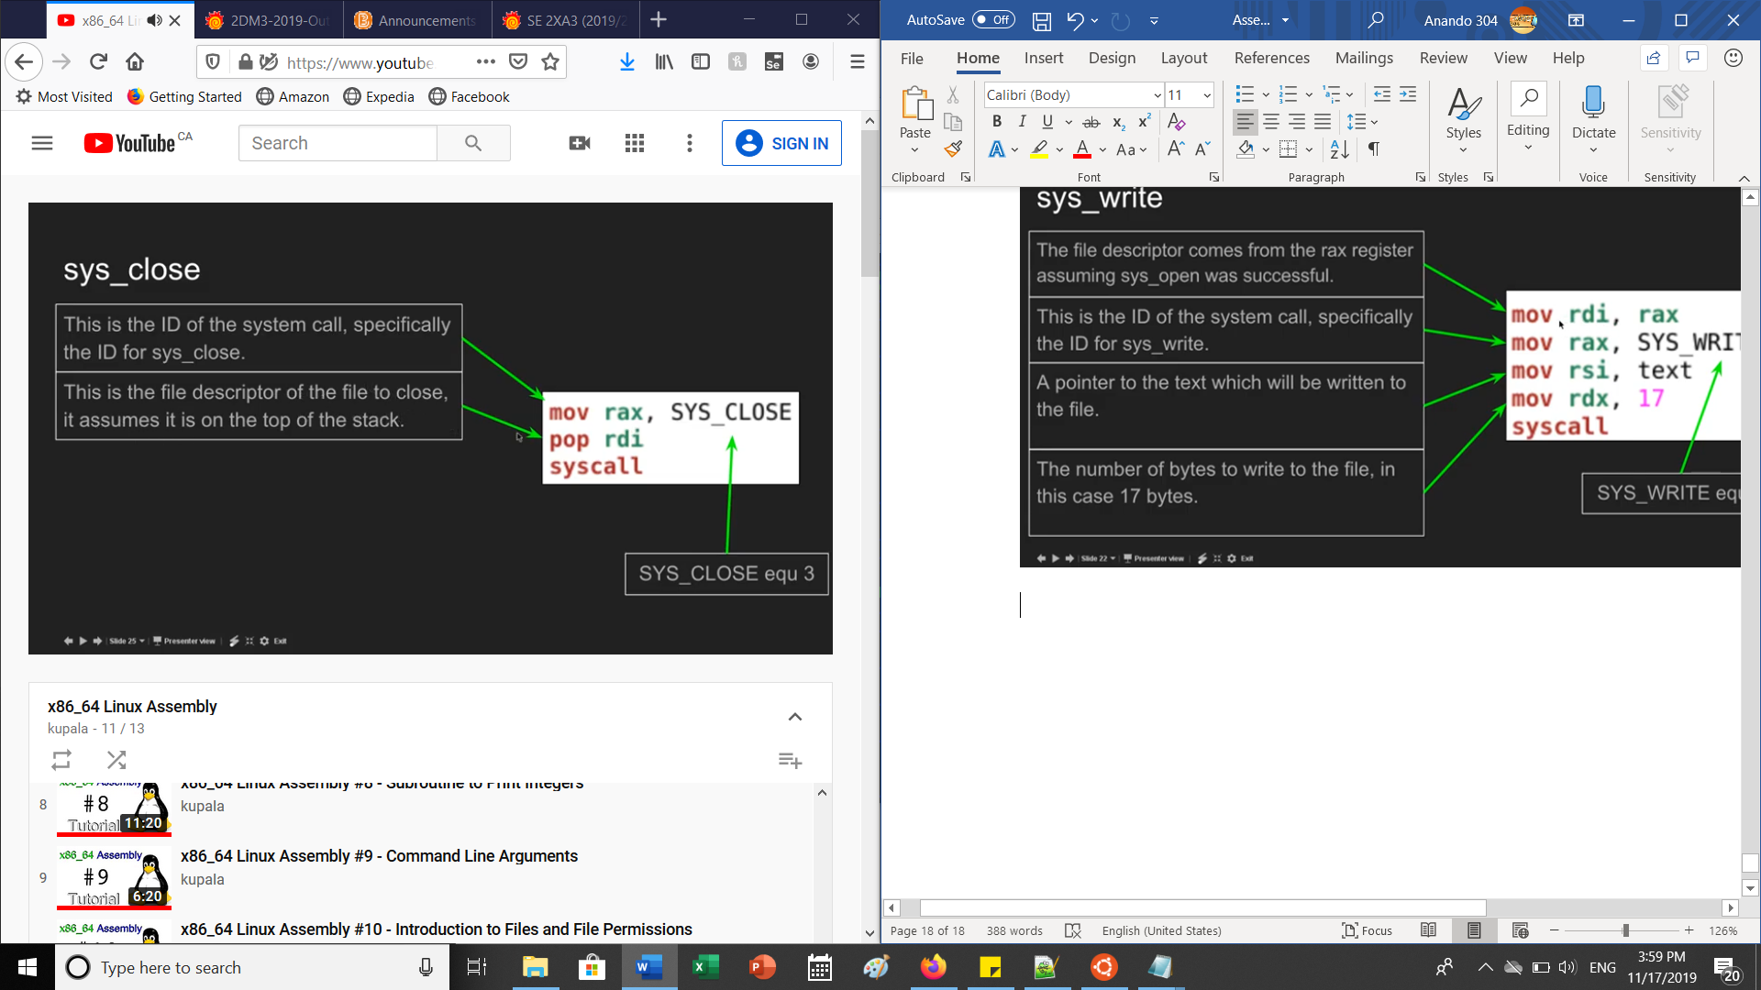

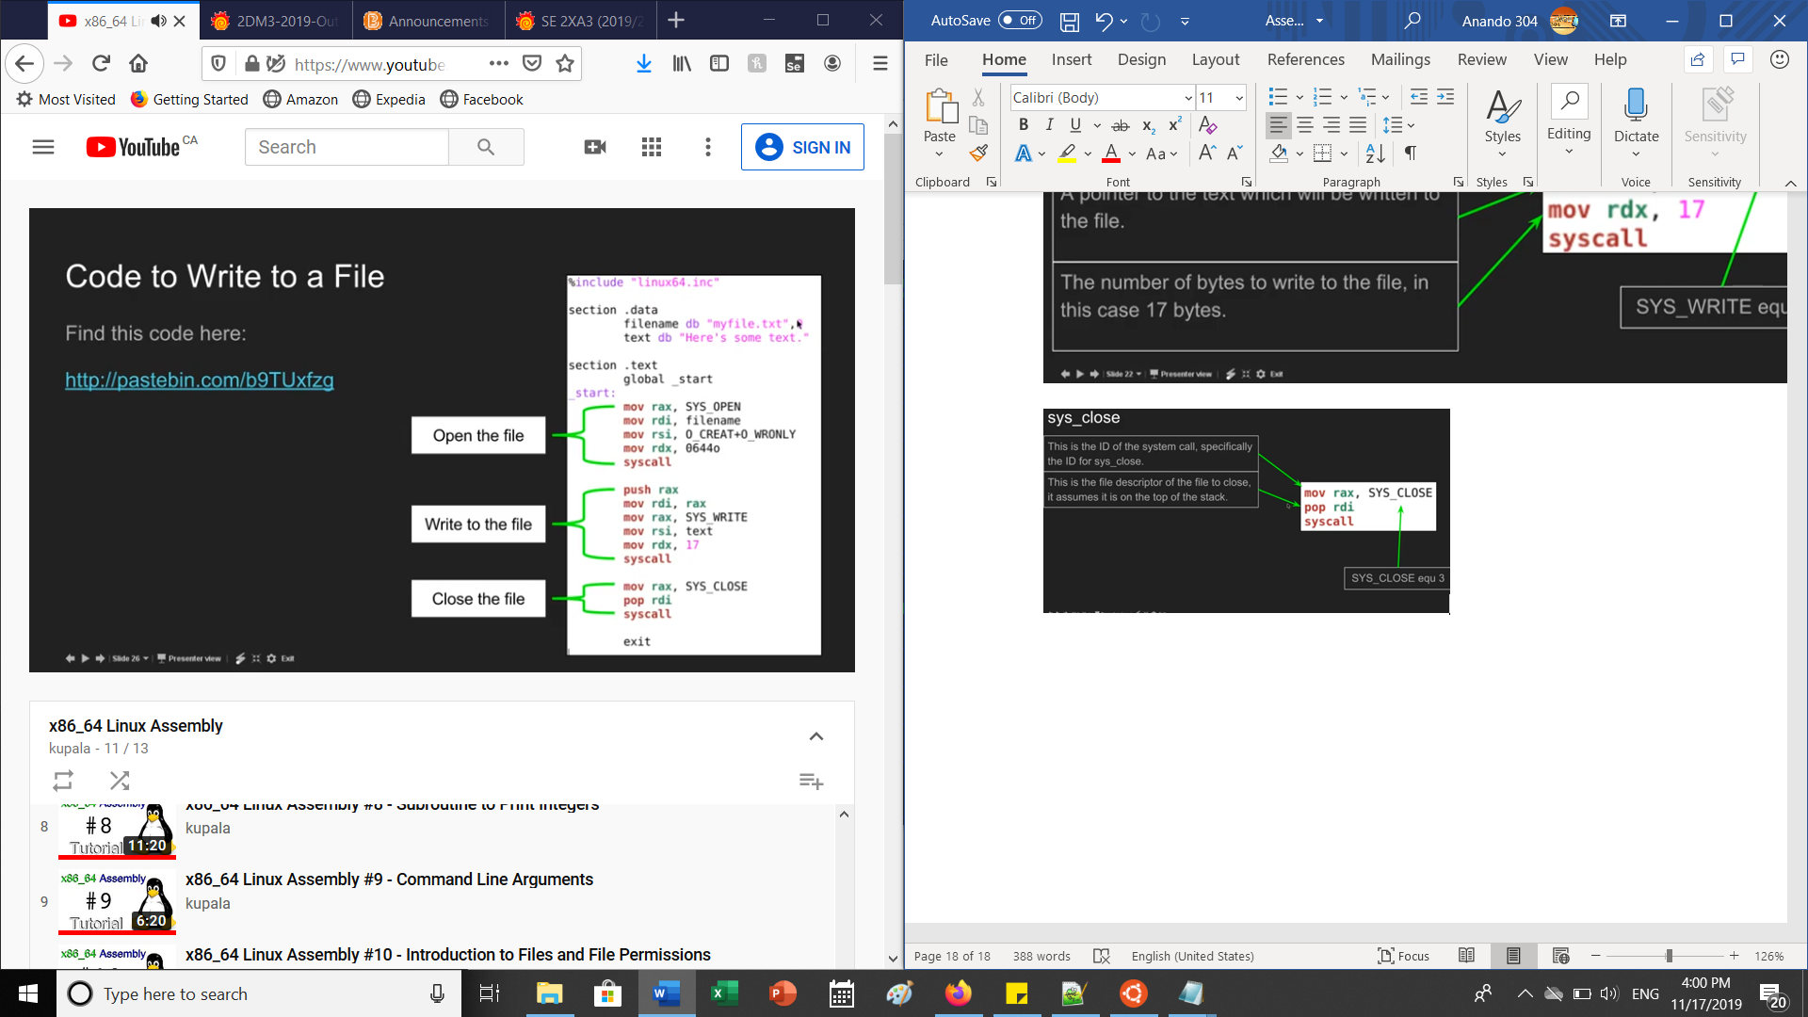

**PART G: READING FILES**

